**Project: UMR Portals**

***Preface***

*This document is an overview on the detailed automated healthcare system of Universal Medical Records institution. Variety of features like user information, user management, patient records, patient demographics, enroll providers, enroll patients etc. are thoroughly described in here. Three basic users of this application are Admin, Doctor and Nurse who can work with their own limitations. Uniform Resource Locator is also added here to navigate to all features directly.* *Onclick Feature Name, it will navigate you to your target image in this document*

***Note: If a child window is opened using frame source link, then there will be error.***

**Project URL:**[**http://umrtest.com/UMRPortals**](http://umrtest.com/UMRPortals)

**Username: admin**

**Pass: Admin#123**

**Done by: UMR QA Team**

***Index***

|  |  |  |  |
| --- | --- | --- | --- |
| **SL** | **Uniform Resource Locator(URL)** | **Feature Name** | **Page No** |
| 1 | <http://umrtest.com/UMRPortals/LogIn.aspx> | Login | 3 |
| 2 | <http://umrtest.com/UMRPortals/SignUp/SignUp.aspx> | Provider Enrollment | 3 |
| 3 | <http://umrtest.com/UMRPortals/SignUp/SignUpPatient.aspx> | Patient Enrollment | 4 |
| 4 | <http://umrtest.com/UMRPortals/ResetPassword/PasswordReset.aspx> | Forgot Your Password | 4 |
| 5 | <http://umrtest.com/UMRPortals/Home/Default.aspx> | Admin Home | 5 |
| 6 | <http://umrtest.com/UMRPortals/Account/Register.aspx> | User Information | 5 |
| 7 | <http://umrtest.com/UMRPortals/Administrative/UserSettings.aspx> | User Settings | 6 |
| 8 | <http://umrtest.com/UMRPortals/Account/ChangePassword.aspx> | Change Password | 6 |
| 9 | <http://umrtest.com/UMRPortals/Administrative/UserManagement.aspx> | User Management | 7 |
| 10 | <http://umrtest.com/UMRPortals/Administrative/GroupManagement.aspx> | Group Management | 7 |
| 11 | <http://umrtest.com/UMRPortals/Administrative/Usages.aspx> | Usage History | 8 |
| 12 | <http://umrtest.com/UMRPortals/PatientFeatures/ProviderCalendar.aspx> | Calendar | 8 |
| 13 | <http://umrtest.com/UMRPortals/PatientFeatures/PatientFeaturesSearch.aspx> | Patient Records | 9 |
| 13.1 | <http://umrtest.com/UMRPortals/PatientFeatures/PatientFeaturesPop.aspx?PatientKey=3> | Medical History Index | 9 |
| 13.1.1 | <http://umrtest.com/UMRPortals/PatientFeatures/MPI.aspx?PatientKey=3> | Master Patient Code Indexes | 10 |
| 13.1.1.1 | <http://umrtest.com/UMRPortals/PatientFeatures/ViewMedcodeHistory.aspx?MedcodeGUID=26a9b6ec-d1ca-410a-984a-5e433007f131> | Medcode History | 10 |
| 13.1.1.2 | <http://umrtest.com/UMRPortals/PatientFeatures/MPI.aspx?PatientKey=3> | Related Disciplines | 11 |
| 13.1.1.3 | <http://umrtest.com/UMRPortals/PatientFeatures/ProviderDetails.aspx?ID=21&DispType=S&HasCode=true&Code=99446&Type=CPT-4&Version=2015&CodeDate=1/8/2015%202:00:21%20PM&PatientKey=3&InstituteCode=UMHLD&DoctorID=211> | Provider Locator | 11 |
| 13.1.1.4 | <http://umrtest.com/UMRPortals/PatientFeatures/InstitutionDetails.aspx?code=10004&PatientKey=3&HasCodeSingle=true&CodeMEDNDC=847.9&Type=ICD-9-CM&Version=2014&DoctorID=13&CodeDate=1/1/2008%2012:00:00%20AM&IsLP=1> | Facility Locator | 12 |
| 13.1.1.5 | <http://umrtest.com/UMRPortals/PatientFeatures/RDDetails.aspx?PatientKey=3&medCode=99446&disType=D&name=Test&desc=Test&rwndrnd=0.6989118887650952> | Diagnosis Details | 12 |
| 13.1.1.6 | <http://umrtest.com/UMRPortals/AlertNetwork/ViewProviderSoap.aspx?AlertId=171063> | SOAP Details | 13 |
| 13.1.1.7 | <http://umrtest.com/UMRPortals/PatientFeatures/RDDetails.aspx?PatientKey=3&disType=N&name=NAPROXEN%20500MG%20TABLET&NDCCode=00378045105&ProviderID=13-LP&InstituteID=10004> | Prescription and Medication Details | 13 |
| 13.1.1.8 | <http://umrtest.com/UMRPortals/PatientFeatures/RefillDetails.aspx?PatientKey=3&UMR_NDC_ID=b6e37e79-5e9a-4d40-9bb1-58253575ac3f&IsLP=1&ProviderID=13> | Refill Details | 14 |
| 13.1.1.9 | <http://umrtest.com/UMRPortals/PatientFeatures/InstituteWiseServiceList.aspx?code=UMHLD&PatientKey=3> | Service List | 14 |
| 13.1.1.10 | <http://umrtest.com/UMRPortals/PatientFeatures/MPI.aspx?PatientKey=3> | Filter | 15 |
| 13.1.1.11 | <http://umrtest.com/UMRPortals/PatientFeatures/MPI.aspx?PatientKey=3> | Clear | 15 |
| 13.1.1.12 | <http://umrtest.com/UMRPortals/PatientFeatures/MPIFax.aspx?PatientKey=3&PageCount=10&filterText>= | Fax | 16 |
| 13.1.1.13 | <http://umrtest.com/UMRPortals/PatientFeatures/MPIEmail.aspx?PatientKey=3&PageCount=10&filterText>= | Email | 16 |
| 13.1.1.14 | <http://umrtest.com/UMRPortals/PatientFeatures/MPIPrintRange.aspx?PatientKey=3&PageCount=10&filterText>= | Print | 16 |
| 13.1.2 | <http://umrtest.com/UMRPortals/PatientFeatures/LRA.aspx?PatientKey=3> | Last Records Accessed Details | 17 |
| 13.1.2.1 | <http://umrtest.com/UMRPortals/PatientFeatures/UserDetails.aspx?UserName=10091&AccessTime=4/4/2017%209:03:53%20AM> | Accessor Details | 17 |
| 13.1.2.2 | <http://umrtest.com/UMRPortals/PatientFeatures/InstitutionProvidersCodes.aspx?code=UMHLD&PatientKey=3> | Service History | 17 |
| 13.1.2.3 | <http://umrtest.com/UMRPortals/PatientFeatures/LRA.aspx?PatientKey=3> | Filter | 17 |
| 13.1.2.4 | <http://umrtest.com/UMRPortals/PatientFeatures/LRAPrintRange.aspx?PatientKey=3&PageCount=353> | Print | 18 |
| 13.1.3 | <http://umrtest.com/UMRPortals/PatientFeatures/UnRD.aspx?PatientKey=3> | Unremarkable Disciplines | 18 |
| 13.1.4 | <http://umrtest.com/UMRPortals/PatientFeatures/MultiProviderListDetails.aspx?PatientKey=3&DispType=M> | Healthcare Providers | 18 |
| 13.1.5 | <http://umrtest.com/UMRPortals/PatientFeatures/AncilliaryHealthCareProviderList.aspx?PatientKey=3> | Ancillary Healthcare Providers | 19 |
| 13.1.6 | <http://umrtest.com/UMRPortals/PatientFeatures/AssociatedAncProvList.aspx?PatientKey=3> | Ancillary Network Contacts | 19 |
| 13.1.7 | <http://umrtest.com/UMRPortals/PatientFeatures/HealthcareFacilities.aspx?PatientKey=3> | Healthcare Facilities | 19 |
| 13.1.8 | <http://umrtest.com/UMRPortals/PatientFeatures/AMD.aspx?PatientKey=3> | Advanced Medical Directive | 19 |
| 13.1.8.1 | <http://umrtest.com/UMRPortals/DataRecord/Report/MOLSTReport.aspx?PatientKey=3> | MOLST Report | 20 |
| 13.1.8.2 | <http://umrtest.com/UMRPortals/DataRecord/Report/MOLSTReport.aspx?PatientKey=3> | MOLST Report >> Show | 20 |
| 13.1.8.3 | <http://umrtest.com/UMRPortals/PatientFeatures/AMDEditor.aspx?PatientKey=3> | Advanced Medical Directives Editor | 20 |
| 13.1.8.4 | <http://umrtest.com/UMRPortals/DataRecord/PatientMOLSTViewer.aspx?PatientKey=3> | MOLST | 20 |
| 13.1.9 | <http://umrtest.com/UMRPortals/PatientFeatures/Emergency.aspx?PatientKey=3> | Emergency Information | 21 |
| 13.1.10 | <http://umrtest.com/UMRPortals/AlertNetwork/AlertChronologyList.aspx?PatientKey=3> | SOAP Chronology | 21 |
| 13.1.10.1 | <http://umrtest.com/UMRPortals/AlertNetwork/ViewAssessmentDetails.aspx?AlertId=171058> | Assessment Details | 21 |
| 13.1.10.2 | <http://umrtest.com/UMRPortals/AlertNetwork/ViewTreatmentDetails.aspx?AlertId=171058> | Treatment Details | 21 |
| 13.1.10.3 | <http://umrtest.com/UMRPortals/AlertNetwork/AlertHistory.aspx?AlertId=171058> | Alert History | 22 |
| 13.1.11 | <http://umrtest.com/UMRPortals/PatientFeatures/Demographic.aspx?PatientKey=3> | Patient Demographics | 22 |
| 13.1.12 | <http://umrtest.com/UMRPortals/PatientFeatures/Insurance.aspx?PatientKey=3> | Insurance Information | 22 |
| 13.1.13 | <http://umrtest.com/UMRPortals/PatientFeatures/PatientSchedule.aspx?PatientKey=3> | Patient Schedule | 22 |
| 13.1.14 | <http://umrtest.com/UMRPortals/PatientFeatures/Legend.aspx?PatientKey=3> | Legend | 23 |
| 13.1.15 | <http://umrtest.com/UMRPortals/PatientFeatures/Disclaimer.aspx> | Disclaimer | 23 |
| 13.1.16 | <http://umrtest.com/UMRPortals/PatientFeatures/RDNew.aspx?PatientKey=3&DisCode=9&DisType=D&DisName=Gastroenterology&CodeType=(CODE_TYPE=@1@%20OR%20CODE_TYPE=@2@%20OR%20CODE_TYPE=@3@%20OR%20CODE_TYPE=@5@)> | Remarkable Disciplines | 23 |
| 13.1.17 | <http://umrtest.com/UMRPortals/PatientFeatures/PrintPreview.aspx?PatientKey=3&SelectedCodeIndex=0,1,2,4> | Preview | 24 |
| 13.2 | <http://umrtest.com/UMRPortals/PatientFeatures/SOAPSelectionWindow.aspx?UserId=10967&PatientKey=3&LastIncompleteStatus=false> | SOAP Entry/Edit Section - 1 | 24 |
| 13.2.1 | <http://umrtest.com/UMRPortals/AlertNetwork/ProviderNotesPop.aspx?PatientKey=3> | SOAP Entry/Edit Section - 2 | 24 |
| 13.2.2 | <http://umrtest.com/UMRPortals/AlertNetwork/ProviderNotesPop.aspx?AlertIdToEdit=171065> | SOAP Entry/Edit Section - 3 | 24 |
| 13.2.3 | <http://umrtest.com/UMRPortals/AlertNetwork/ProviderNotesPop.aspx?AlertIdToEdit=171065> | SOAP Entry/Edit Section - 4 | 25 |
| 13.2.4 | <http://umrtest.com/UMRPortals/AlertNetwork/ProviderNotesPop.aspx?AlertIdToEdit=171065> | SOAP Entry/Edit Section - 5 | 25 |
| 13.2.5 | <http://umrtest.com/UMRPortals/AlertNetwork/ProviderNotesPop.aspx?AlertIdToEdit=171065> | SOAP Entry/Edit Section - 6 | 25 |
| 13.2.6 | <http://umrtest.com/UMRPortals/AlertNetwork/ProviderNotesPop.aspx?AlertIdToEdit=171065> | SOAP Entry/Edit Section - 7 | 26 |
| 14 | <http://umrtest.com/UMRPortals/PatientFeatures/PatientFeatures.aspx> | Record Viewer | 26 |
| 15 | <http://umrtest.com/UMRPortals/DataRecord/PatientDemographics.aspx> | Demographics >> Additional Information | 26 |
| 15.1 | <http://umrtest.com/UMRPortals/DataRecord/PatientDemographics.aspx> | Demographics >> Address | 27 |
| 15.2 | <http://umrtest.com/UMRPortals/DataRecord/PatientDemographics.aspx> | Demographics >> Phone | 27 |
| 15.3 | <http://umrtest.com/UMRPortals/DataRecord/PatientDemographics.aspx> | Demographics >> Education | 27 |
| 15.4 | <http://umrtest.com/UMRPortals/DataRecord/PatientDemographics.aspx> | Demographics >> Employment | 28 |
| 15.5 | <http://umrtest.com/UMRPortals/DataRecord/PatientDemographics.aspx> | Demographics >> Advanced Medical Directive | 28 |
| 16 | <http://umrtest.com/UMRPortals/DataRecord/DemographicsViewer.aspx> | Demographics Viewer | 28 |
| 16.1 | <http://umrtest.com/UMRPortals/DataRecord/DemographicsViewer.aspx> | Demographics Viewer Show | 29 |
| 17 | <http://umrtest.com/UMRPortals/DataRecord/DemographicsEditor.aspx> | Demographics Editor | 29 |
| 17.1 | <http://umrtest.com/UMRPortals/DataRecord/PatientDemographicsPop.aspx?PatientKey=3> | Demographics Editor >> Additional Information | 30 |
| 17.2 | <http://umrtest.com/UMRPortals/DataRecord/PatientDemographicsPop.aspx?PatientKey=3> | Demographics Editor >> Address | 30 |
| 17.3 | <http://umrtest.com/UMRPortals/DataRecord/PatientDemographicsPop.aspx?PatientKey=3> | Demographics Editor >> Phone | 31 |
| 17.4 | <http://umrtest.com/UMRPortals/DataRecord/PatientDemographicsPop.aspx?PatientKey=3> | Demographics Editor >> Education | 31 |
| 17.5 | <http://umrtest.com/UMRPortals/DataRecord/PatientDemographicsPop.aspx?PatientKey=3> | Demographics Editor >> Employment | 32 |
| 17.6 | <http://umrtest.com/UMRPortals/DataRecord/PatientDemographicsPop.aspx?PatientKey=3> | Demographics Editor >> Advanced Medical Directive | 32 |
| 17.7 | <http://umrtest.com/UMRPortals/DataRecord/PatientDemographicsPop.aspx?PatientKey=3> | Demographics Editor >> Photo Upload | 33 |
| 18 | <http://umrtest.com/UMRPortals/AlertNetwork/ProviderNotes.aspx> | Alert Network >> Create SOAP Notes | 33 |
| 18.1 | <http://umrtest.com/UMRPortals/AlertNetwork/AlertNetworkManagement.aspx> | Alert Network >> Alert Management | 34 |
| 18.1.1 | <http://umrtest.com/UMRPortals/AlertNetwork/ViewProviderSoap.aspx?AlertId=171063> | Alert Management >> SOAP Details | 34 |
| 18.1.2 | <http://umrtest.com/UMRPortals/AlertNetwork/AlertHistory.aspx?AlertId=171063> | Alert Management >> Alert History | 35 |
| 18.1.3 | <http://umrtest.com/UMRPortals/AlertNetwork/Dispatcher.aspx?AlertId=171067> | Alert Management >> Send To | 35 |
| 18.2 | <http://umrtest.com/UMRPortals/AlertNetwork/IncomingAlert.aspx> | Alert Network >> Incoming SOAP Alert | 36 |
| 18.3 | <http://umrtest.com/UMRPortals/AlertNetwork/OutgoingAlert.aspx> | Alert Network >> Outgoing SOAP Alert | 36 |
| 18.4 | <http://umrtest.com/UMRPortals/AlertNetwork/AlertChronology.aspx> | Alert Network >> SOAP Chronology | 37 |
| 18.4.1 | <http://umrtest.com/UMRPortals/AlertNetwork/AlertChronologyList.aspx?PatientKey=3> | SOAP Chronology >> List | 37 |
| 19 | <http://umrtest.com/UMRPortals/PatientFeatures/PatientSecondUserMgt.aspx> | Patient’s Ancillary Providers | 38 |
| 20 | <http://umrtest.com/UMRPortals/Administrative/ManageSecondaryUser.aspx> | Admin’s Ancillary Providers | 38 |
| 21 | <http://umrtest.com/UMRPortals/Administrative/SignUpAprroval.aspx> | Enroll Providers | 39 |
| 22 | <http://umrtest.com/UMRPortals/Administrative/SingUpApprovalPatient.aspx> | Enroll Patients | 39 |

1. **<http://umrtest.com/UMRPortals/LogIn.aspx>**

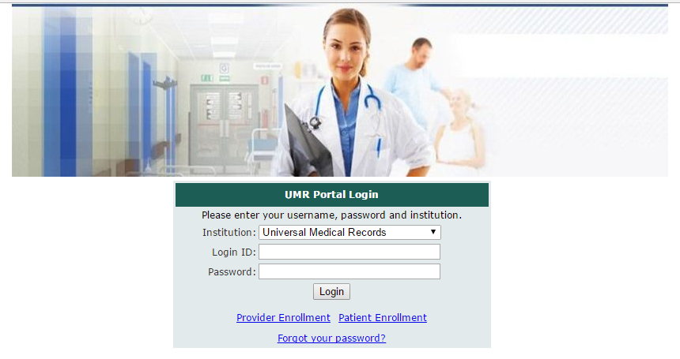

**(Image 1: Login)**

1. **<http://umrtest.com/UMRPortals/SignUp/SignUp.aspx>**

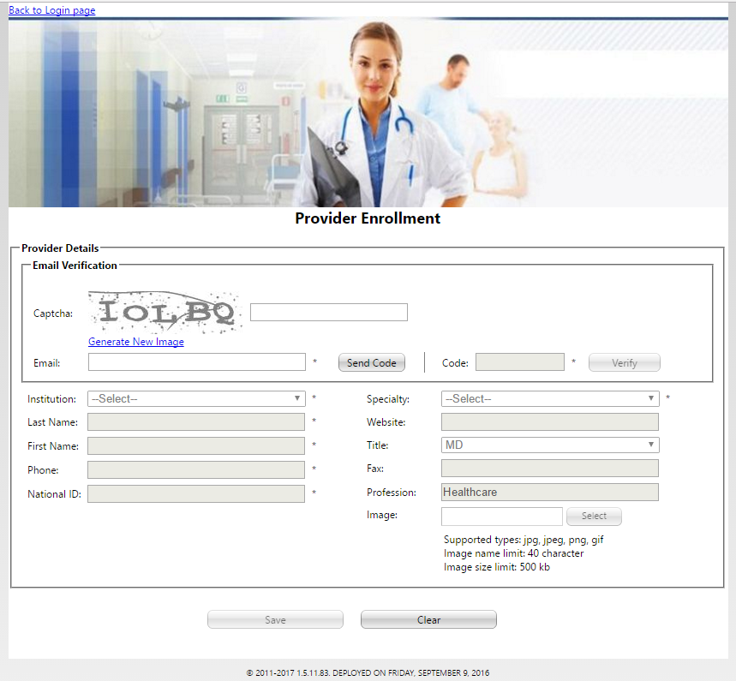

**(Image 2: Provider Enrollment)**

***Back to index***

1. **<http://umrtest.com/UMRPortals/SignUp/SignUpPatient.aspx>**

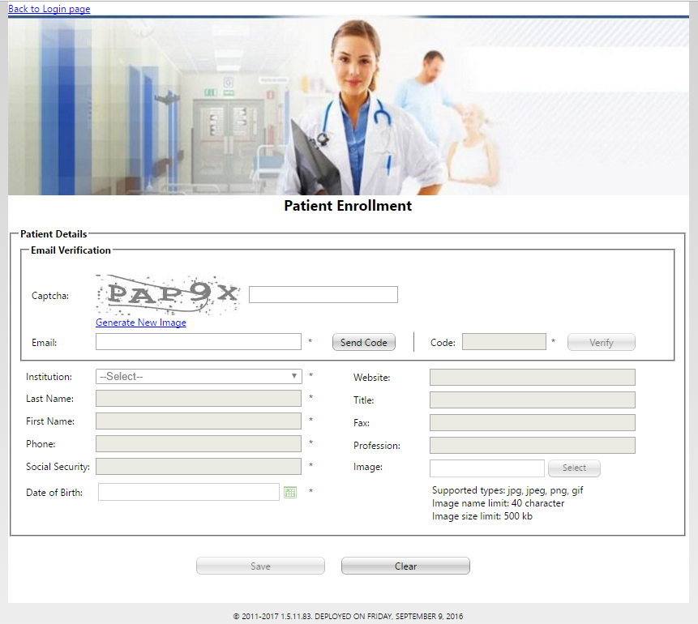

**(Image 3: Patient Enrollment)**

1. **<http://umrtest.com/UMRPortals/ResetPassword/PasswordReset.aspx>**

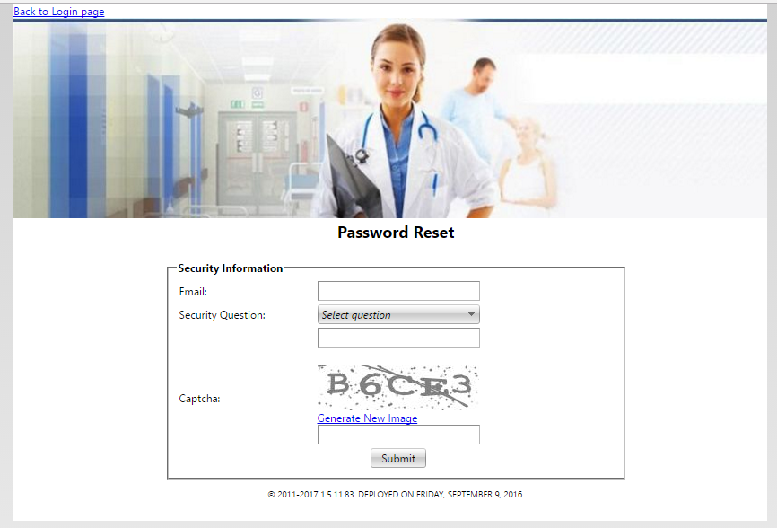

**(Image 4: Forgot Your Password)**

***Back to index***

1. **<http://umrtest.com/UMRPortals/Home/Default.aspx>**

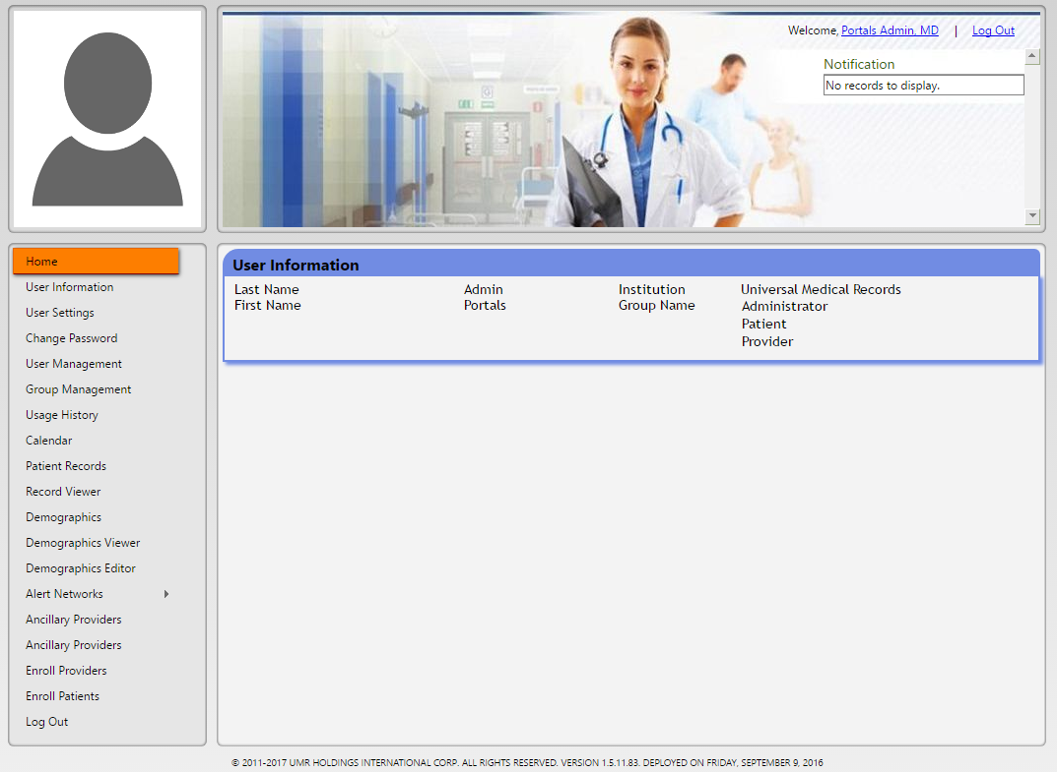

**(Image 5: Admin Home)**

1. **<http://umrtest.com/UMRPortals/Account/Register.aspx>**

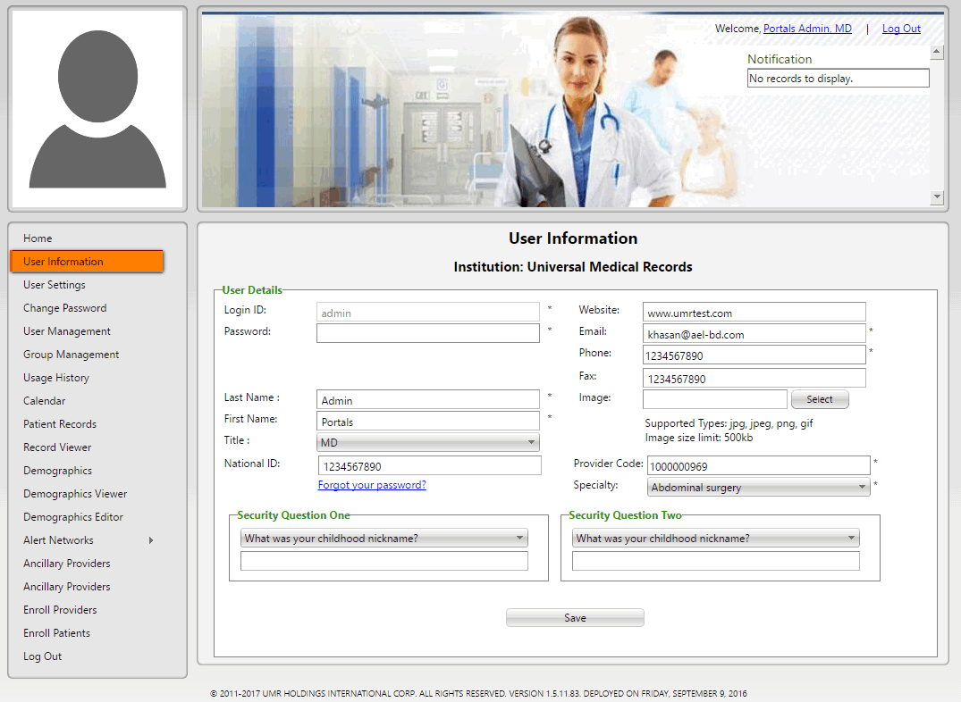

**(Image 6: User Information)**

***Back to index***

1. **<http://umrtest.com/UMRPortals/Administrative/UserSettings.aspx>**

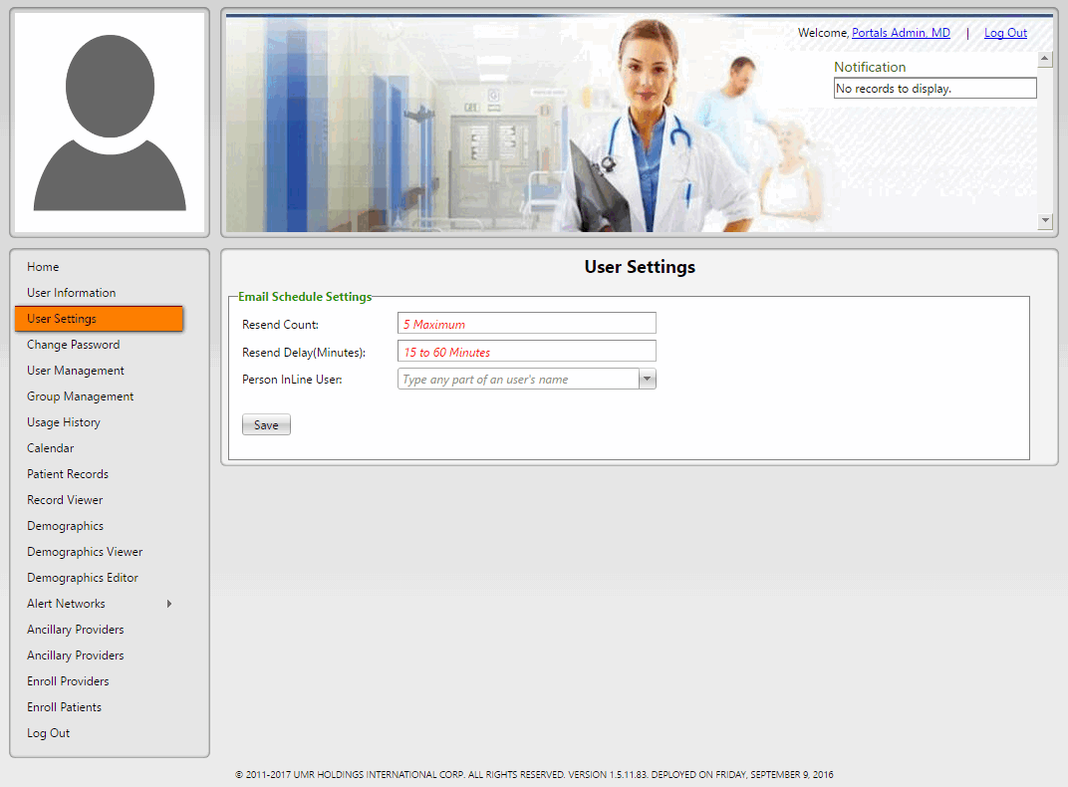

**(Image 7: User Settings)**

1. **<http://umrtest.com/UMRPortals/Account/ChangePassword.aspx>**

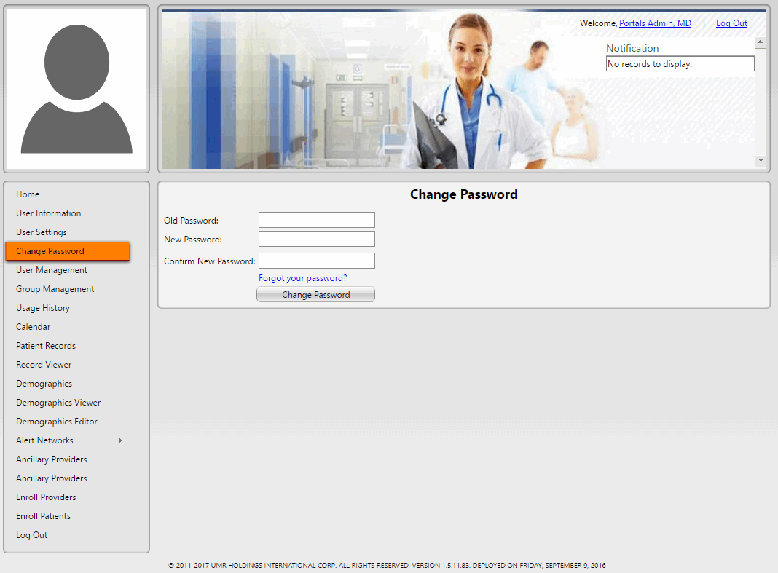

**(Image 8: Change Password)**

***Back to index***

1. **<http://umrtest.com/UMRPortals/Administrative/UserManagement.aspx>**

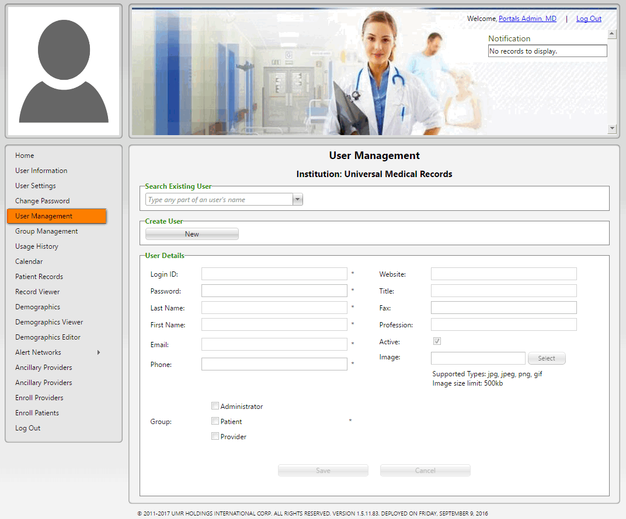

**(Image 9: User Management)**

1. **<http://umrtest.com/UMRPortals/Administrative/GroupManagement.aspx>**

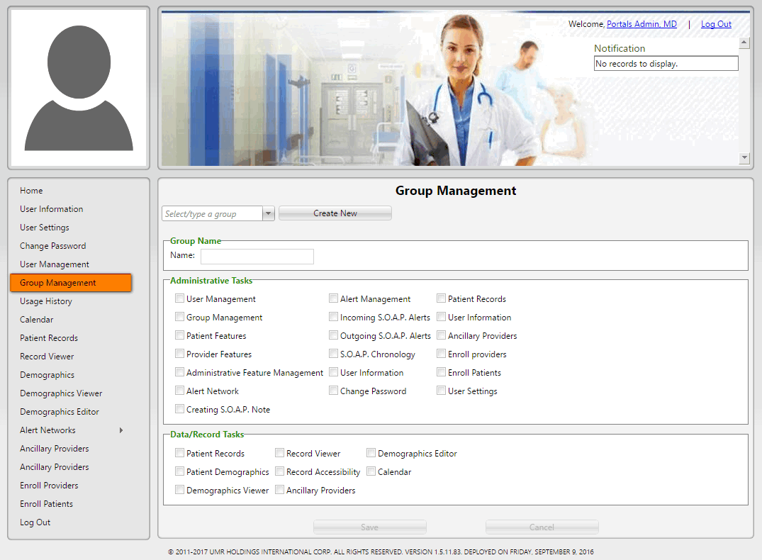

**(Image 10: Group Management)**

***Back to index***

1. **<http://umrtest.com/UMRPortals/Administrative/Usages.aspx>**

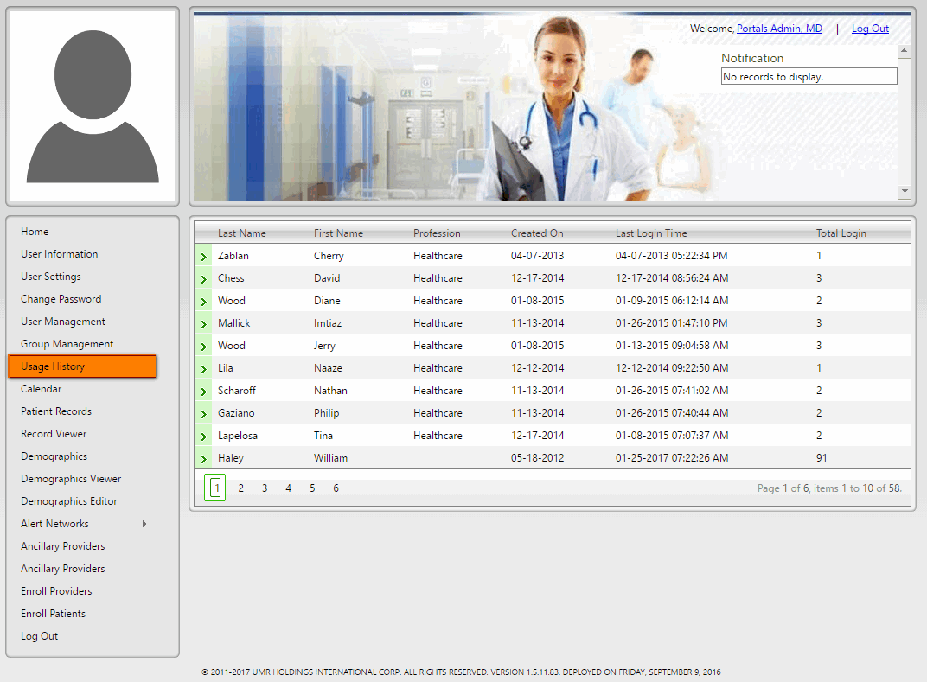

**(Image 11: Usage History)**

1. **<http://umrtest.com/UMRPortals/PatientFeatures/ProviderCalendar.aspx>**

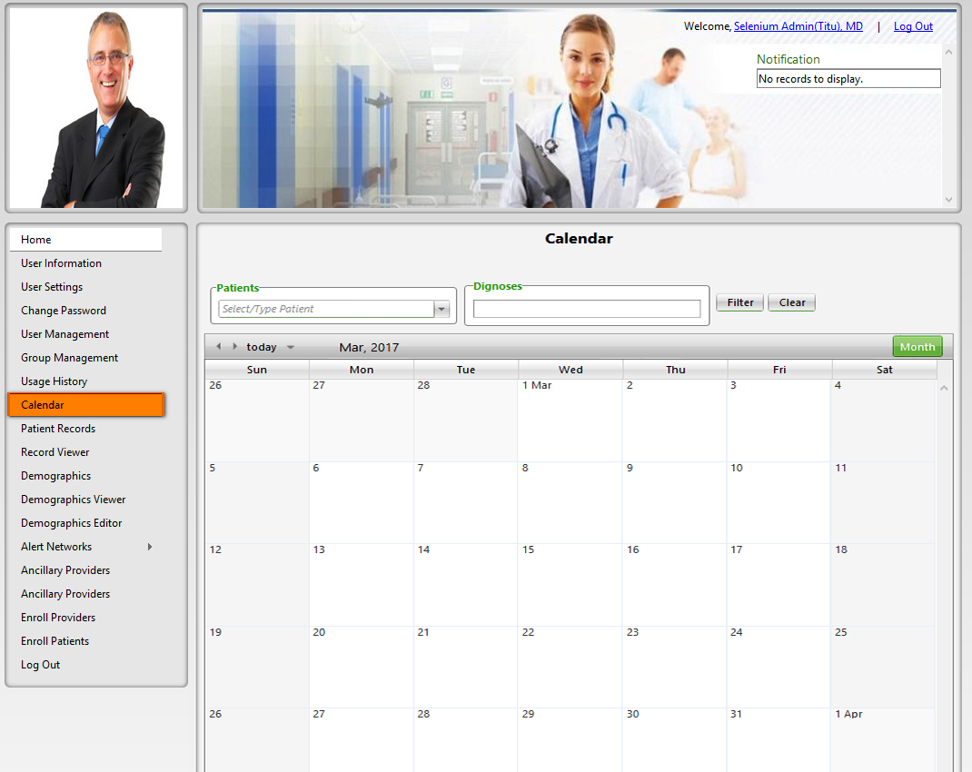

**(Image 12: Calendar)**

***Back to index***

1. **<http://umrtest.com/UMRPortals/PatientFeatures/PatientFeaturesSearch.aspx>**

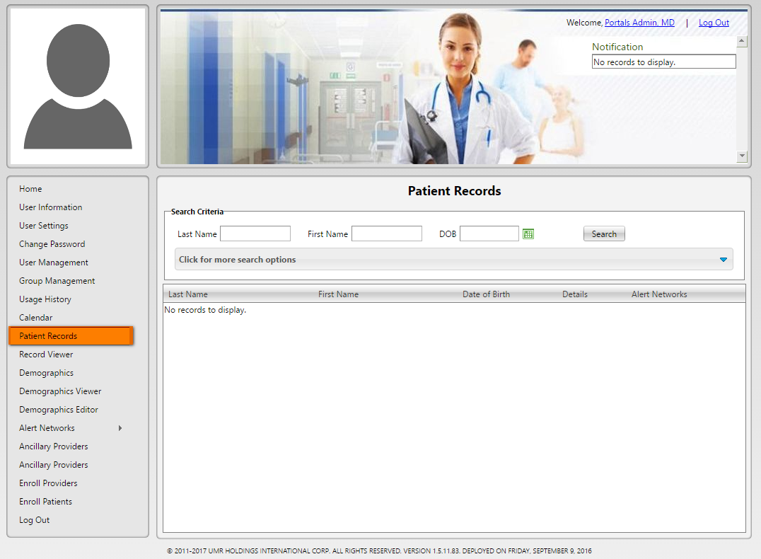

**(Image 13: Patient Records)**

**13.1)** **<http://umrtest.com/UMRPortals/PatientFeatures/PatientFeaturesSearch.aspx>**

[**http://umrtest.com/UMRPortals/PatientFeatures/PatientFeaturesPop.aspx?PatientKey=3**](http://umrtest.com/UMRPortals/PatientFeatures/PatientFeaturesPop.aspx?PatientKey=3)

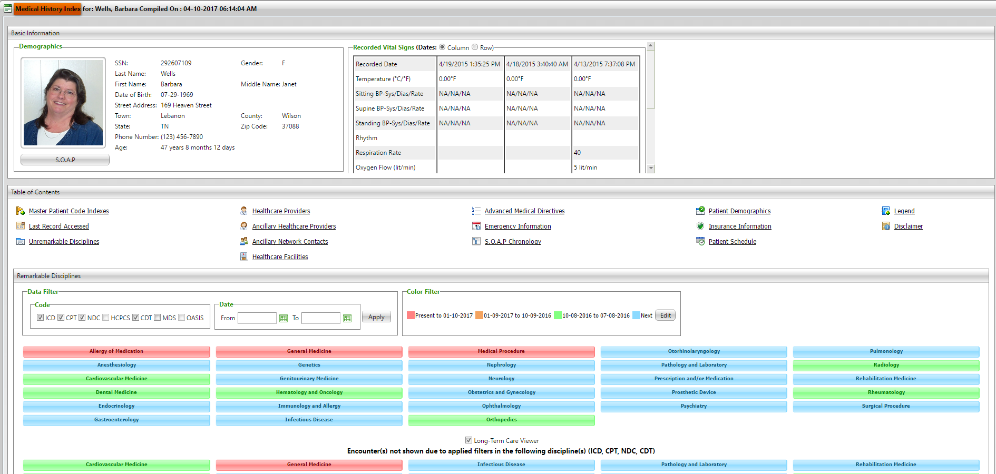

**(Image 13.1: Medical History Index)**

***Back to index***

**13.1.1)** **<http://umrtest.com/UMRPortals/PatientFeatures/MPI.aspx?PatientKey=3>**

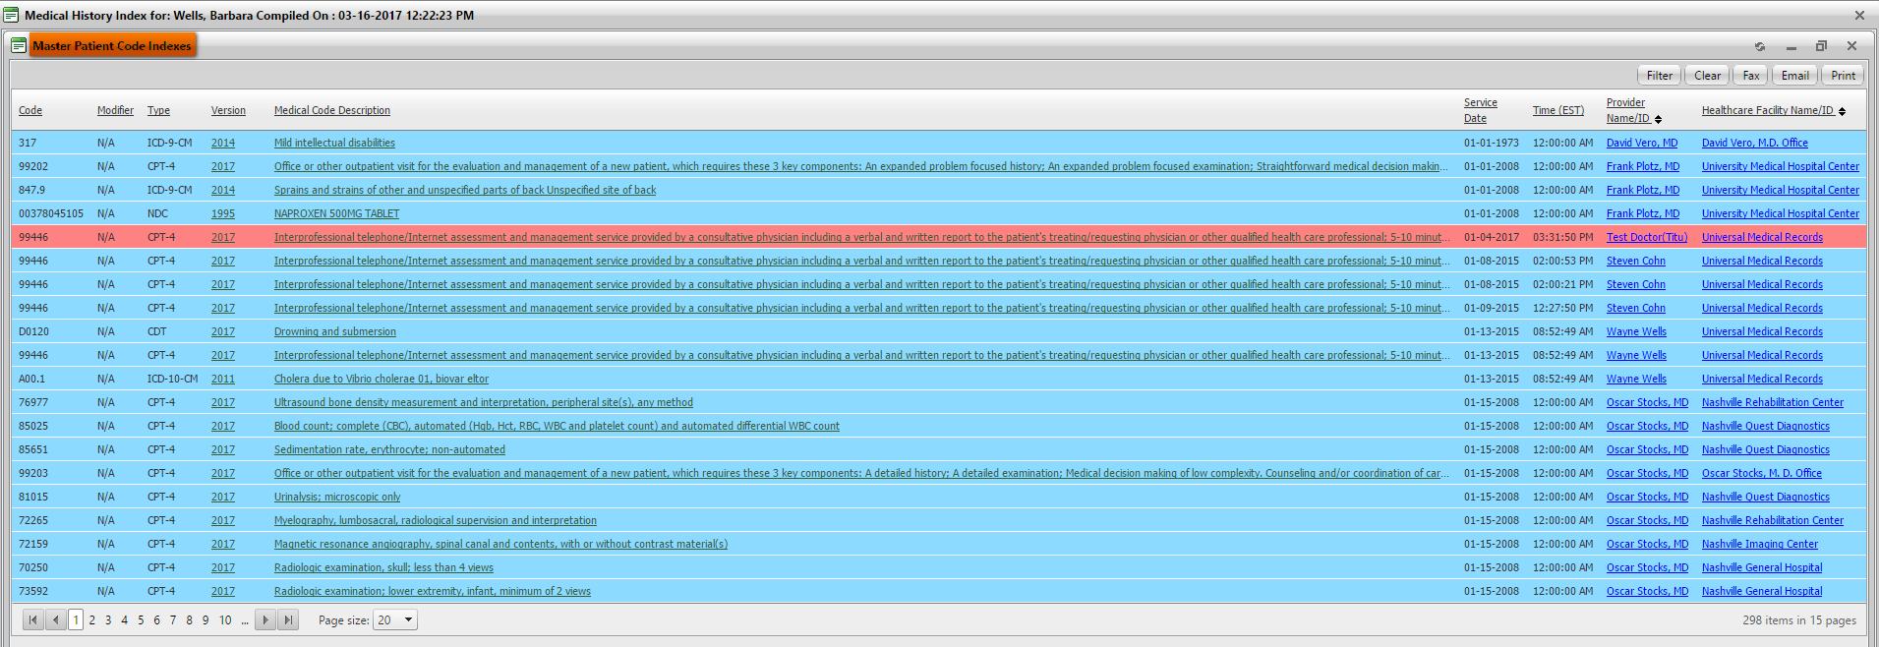

**(Image 13.1.1: Master Patient Code Indexes)**

**13.1.1.1)****<http://umrtest.com/UMRPortals/PatientFeatures/ViewMedcodeHistory.aspx?MedcodeGUID=26a9b6ec-d1ca-410a-984a-5e433007f131>**

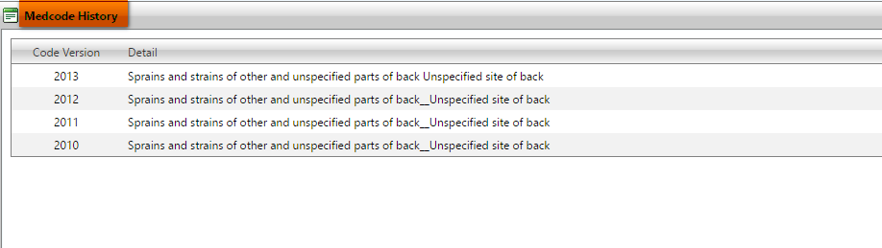

**(Image 13.1.1.1: Medcode History)**

**13.1.1.2)**[**http://umrtest.com/UMRPortals/PatientFeatures/MPI.aspx?PatientKey=3**](http://umrtest.com/UMRPortals/PatientFeatures/MPI.aspx?PatientKey=3)

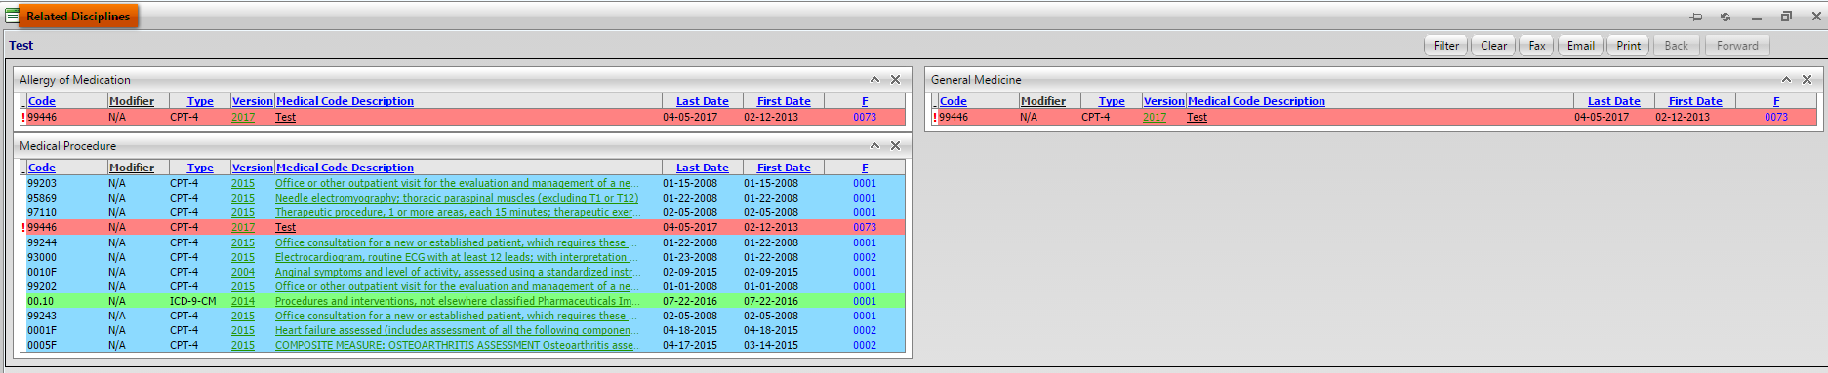

**(Image 13.1.1.2: Related Disciplines)**

**NOTE: Other links are related to Medcode History(Image 13.1.1.1), Related Disciplines(Image 13.1.1.2 All).**

***Back to index***

**13.1.1.3)****<http://umrtest.com/UMRPortals/PatientFeatures/ProviderDetails.aspx?ID=21&DispType=S&HasCode=true&Code=99446&Type=CPT-4&Version=2015&CodeDate=1/8/2015%202:00:21%20PM&PatientKey=3&InstituteCode=UMHLD&DoctorID=211>**

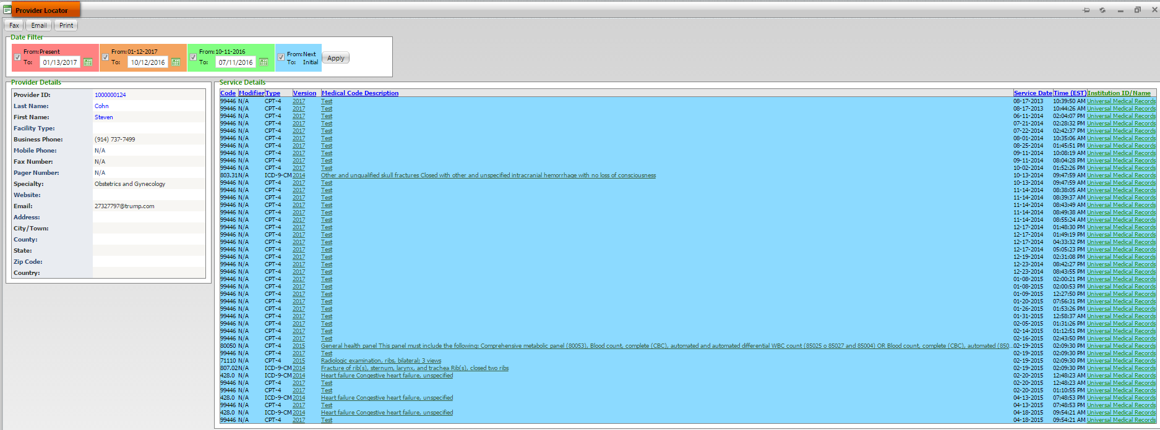

**(Image 13.1.1.3: Provider Locator)**

**13.1.1.4)****<http://umrtest.com/UMRPortals/PatientFeatures/InstitutionDetails.aspx?code=10004&PatientKey=3&HasCodeSingle=true&CodeMEDNDC=847.9&Type=ICD-9-CM&Version=2014&DoctorID=13&CodeDate=1/1/2008%2012:00:00%20AM&IsLP=1>**

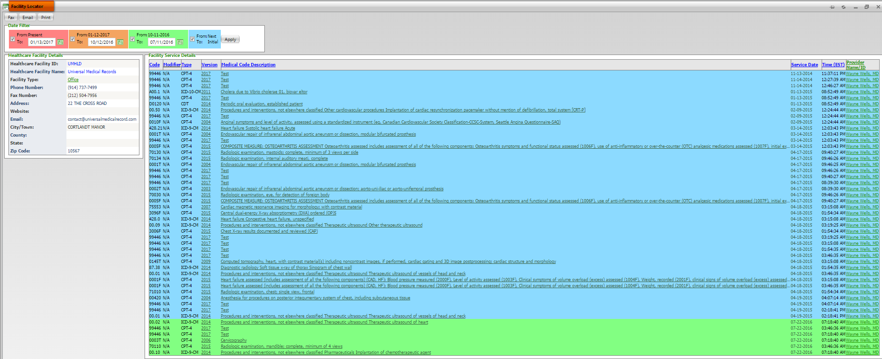

**(Image 13.1.1.4: Facility Locator)**

***Back to index***

**13.1.1.5)****<http://umrtest.com/UMRPortals/PatientFeatures/RDDetails.aspx?PatientKey=3&medCode=99446&disType=D&name=Test&desc=Test&rwndrnd=0.6989118887650952>**

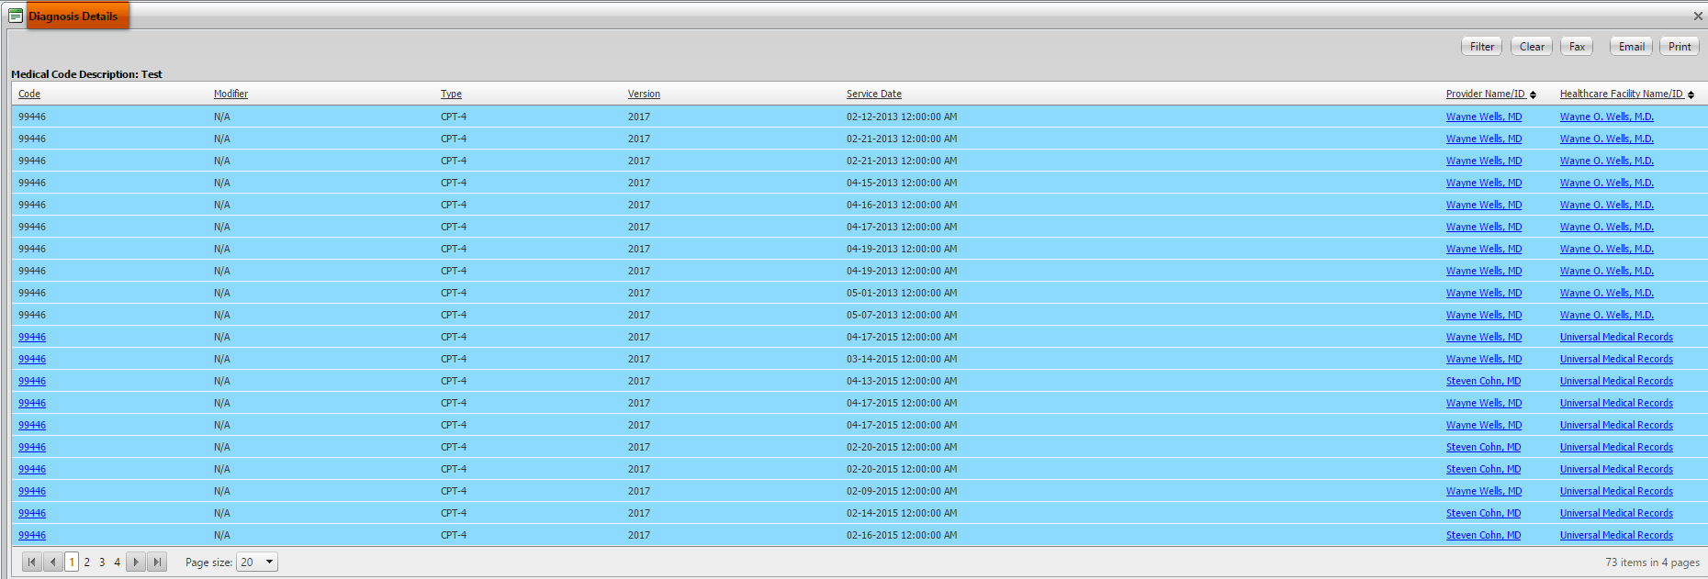

**(Image 13.1.1.5: Diagnosis Details)**

**13.1.1.6)** **<http://umrtest.com/UMRPortals/AlertNetwork/ViewProviderSoap.aspx?AlertId=171063>**

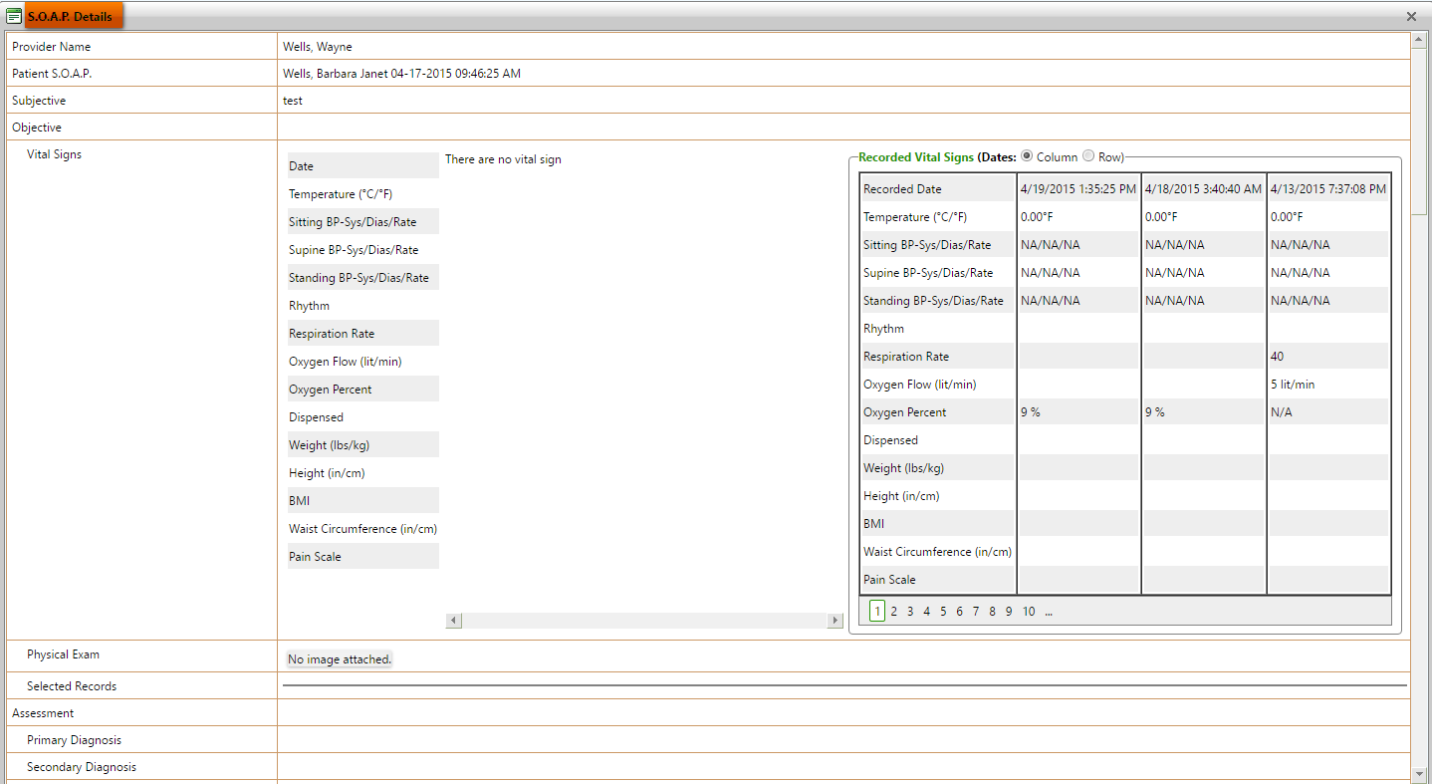

**(Image 13.1.1.6: SOAP Details)**

**13.1.1.7)****<http://umrtest.com/UMRPortals/PatientFeatures/RDDetails.aspx?PatientKey=3&disType=N&name=NAPROXEN%20500MG%20TABLET&NDCCode=00378045105&ProviderID=13-LP&InstituteID=10004>**

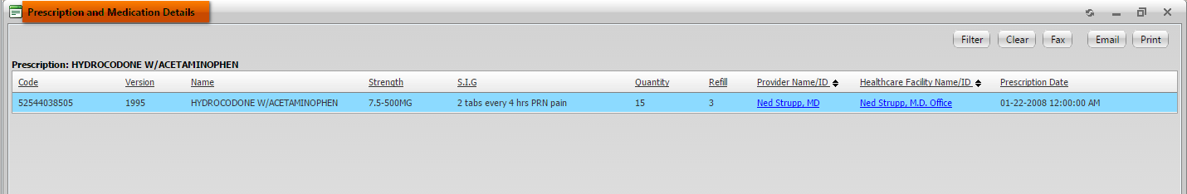

**(Image 13.1.1.7: Prescription and Medication Details)**

**NOTE: Other links are related to Provider Locator(Image 13.1.1.3 All), Facility Locator(Image 13.1.1.4 All).**

***Back to index***

**13.1.1.8)****<http://umrtest.com/UMRPortals/PatientFeatures/RefillDetails.aspx?PatientKey=3&UMR_NDC_ID=b6e37e79-5e9a-4d40-9bb1-58253575ac3f&IsLP=1&ProviderID=13>**

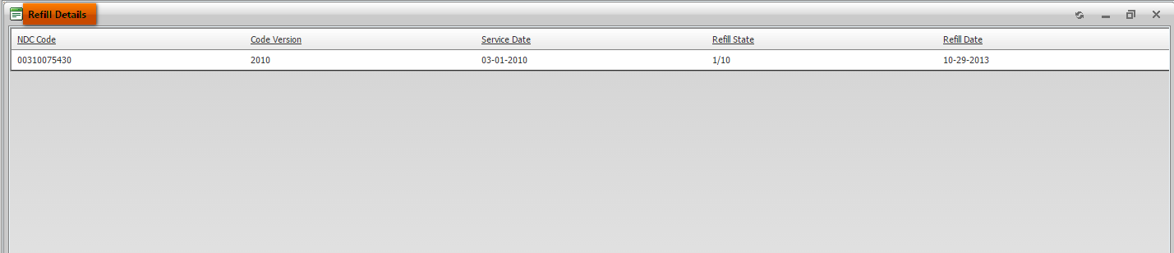

**(Image 13.1.1.8: Refill Details)**

**13.1.1.9)****<http://umrtest.com/UMRPortals/PatientFeatures/InstituteWiseServiceList.aspx?code=UMHLD&PatientKey=3>**

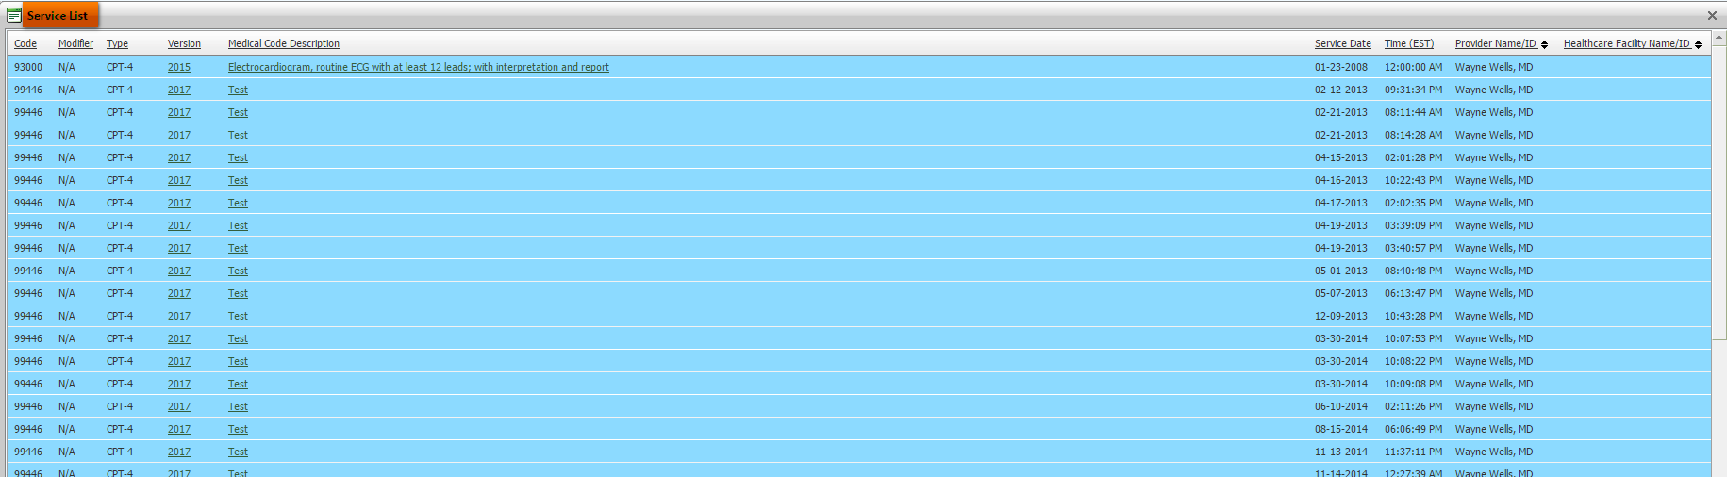

**(Image 13.1.1.9: Service List)**

**NOTE: Other links are related to Medcode History(Image 13.1.1.1), Related Disciplines(Image 13.1.1.2 All).**

**13.1.1.10)** **<http://umrtest.com/UMRPortals/PatientFeatures/MPI.aspx?PatientKey=3>**

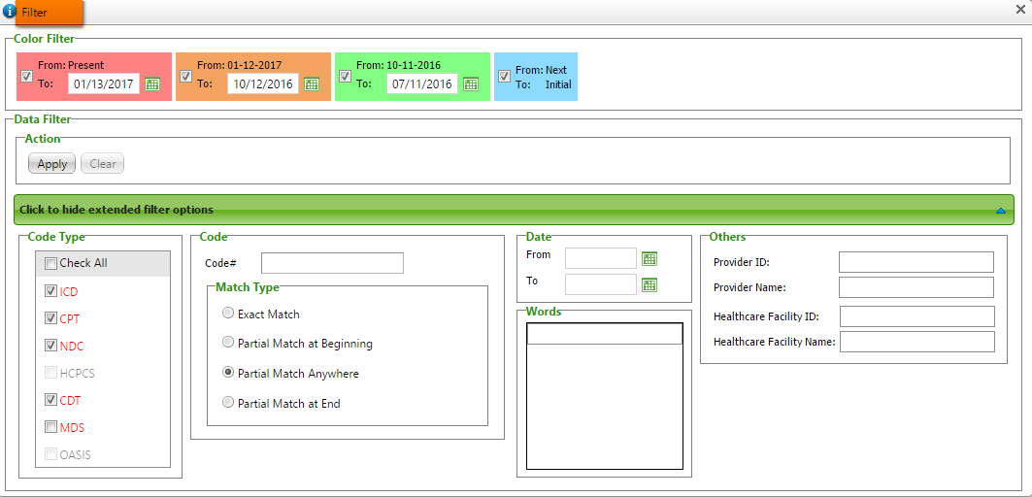

**(Image 13.1.1.10: Filter)**

***Back to index***

**13.1.1.11)** **<http://umrtest.com/UMRPortals/PatientFeatures/MPI.aspx?PatientKey=3>**

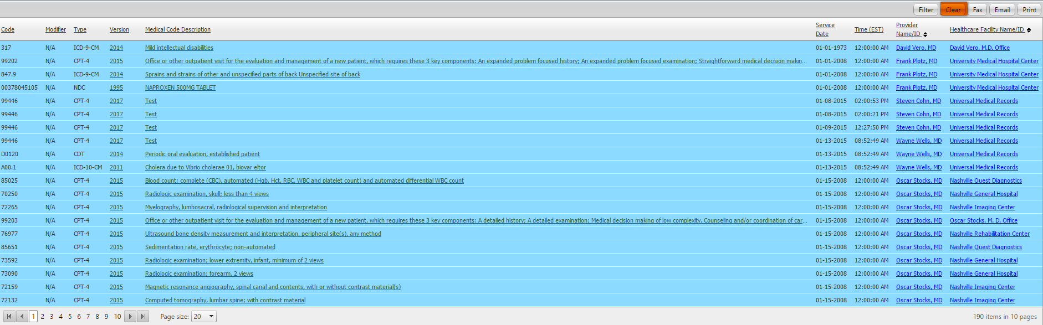

**(Image 13.1.1.11: Clear)**

**13.1.1.12)****<http://umrtest.com/UMRPortals/PatientFeatures/MPIFax.aspx?PatientKey=3&PageCount=10&filterText>=**

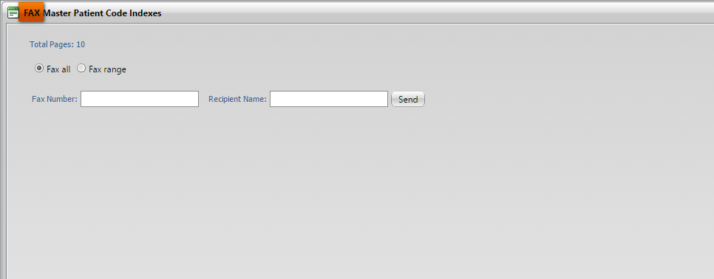

**(Image 13.1.1.12: Fax)**

**13.1.1.13)****<http://umrtest.com/UMRPortals/PatientFeatures/MPIEmail.aspx?PatientKey=3&PageCount=10&filterText>=**

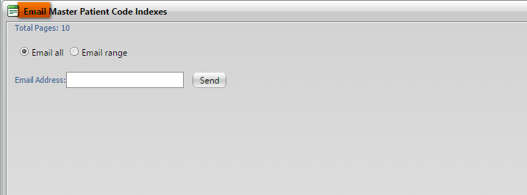

**(Image 13.1.1.13: Email)**

***Back to index***

**13.1.1.14)****<http://umrtest.com/UMRPortals/PatientFeatures/MPIPrintRange.aspx?PatientKey=3&PageCount=10&filterText>=**

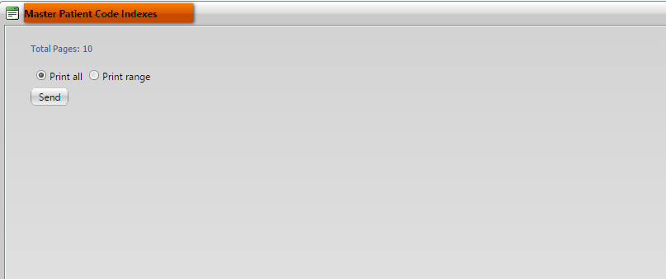

**(Image 13.1.1.14: print)**

**13.1.2)** **<http://umrtest.com/UMRPortals/PatientFeatures/LRA.aspx?PatientKey=3>**

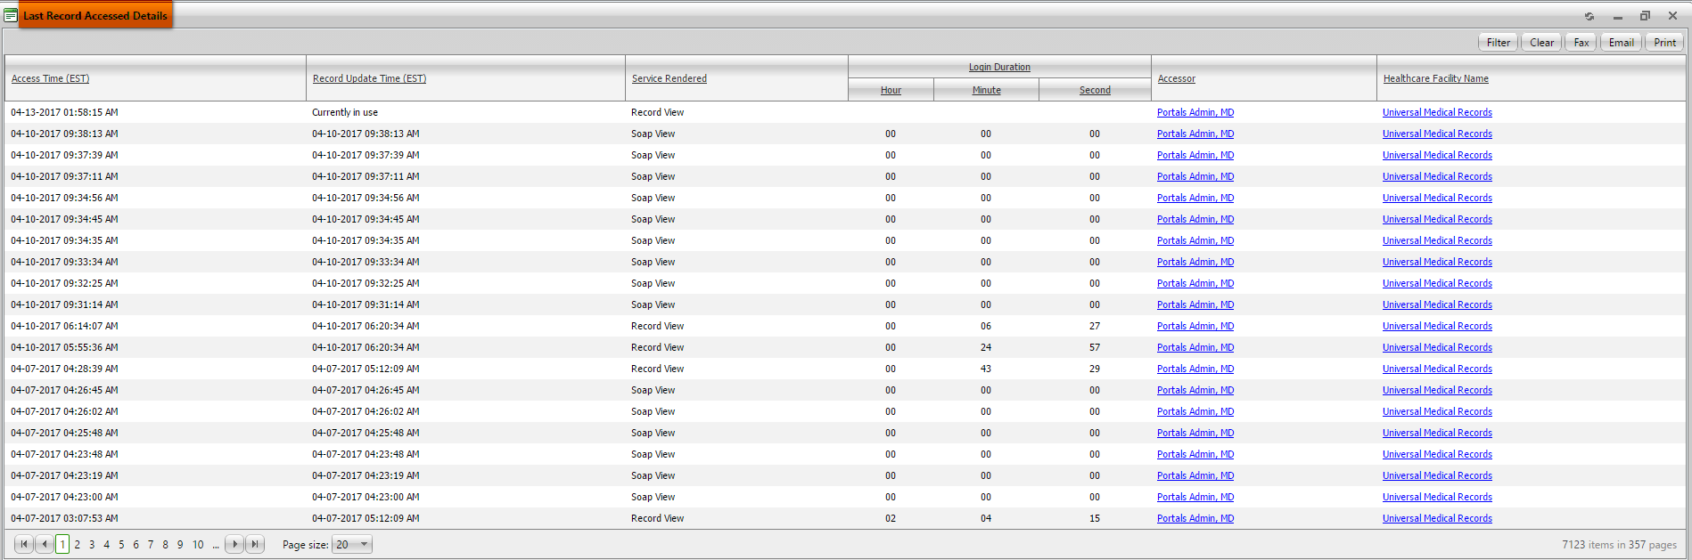

**(Last Records Accessed Details)**

**13.1.2.1)****<http://umrtest.com/UMRPortals/PatientFeatures/UserDetails.aspx?UserName=10091&AccessTime=4/4/2017%209:03:53%20AM>**

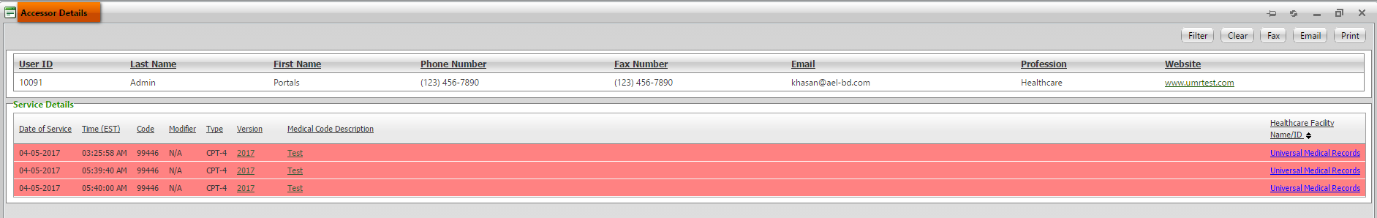

**(Image 13.1.2.1: Accessor Details)**

**NOTE: Other links are related to Medcode History(Image 13.1.1.1), Related Disciplines(Image 13.1.1.2 All), Facility Locator(Image 13.1.1.5 All)**

***Back to index***

**13.1.2.2)****<http://umrtest.com/UMRPortals/PatientFeatures/InstitutionProvidersCodes.aspx?code=UMHLD&PatientKey=3>**

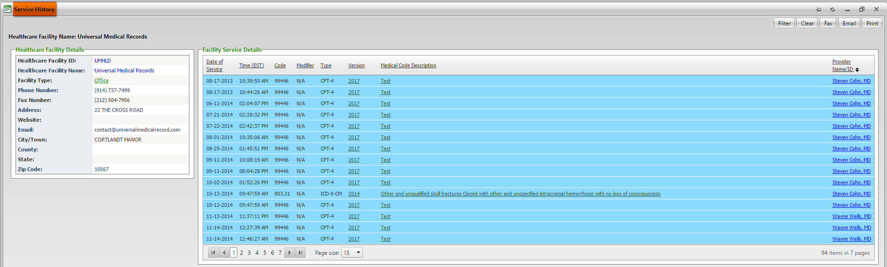

**(Image 13.1.2.2: Service History)**

**NOTE: Other links are related to Medcode History(Image 13.1.1.1), Related Disciplines(Image 13.1.1.2 All), Provider Locator(Image 13.1.1.4 All), Service List(Image 13.1.1.9 All)**

**13.1.2.3)** **<http://umrtest.com/UMRPortals/PatientFeatures/LRA.aspx?PatientKey=3>**

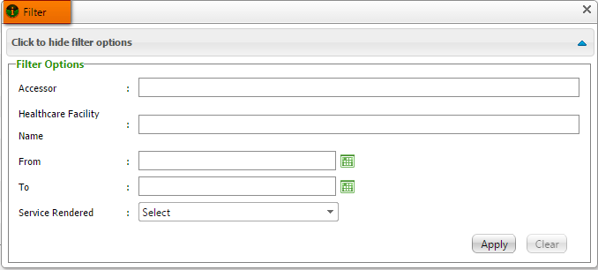

**(Image 13.1.2.3: Filter)**

**13.1.2.4)****<http://umrtest.com/UMRPortals/PatientFeatures/LRAPrintRange.aspx?PatientKey=3&PageCount=353>**

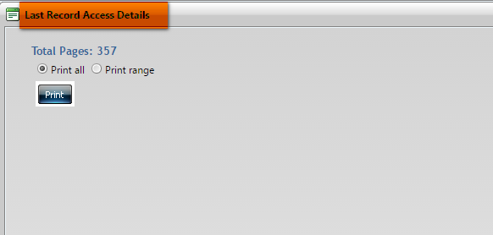

**(Image 13.1.2.4: Print)**

**NOTE: Fax, Clear and Email links are related Fax(Image 13.1.1.12), Clear(Image 13.1.1.11) and Email(Image 13.1.1.13).**

***Back to index***

**13.1.3)** **<http://umrtest.com/UMRPortals/PatientFeatures/UnRD.aspx?PatientKey=3>**

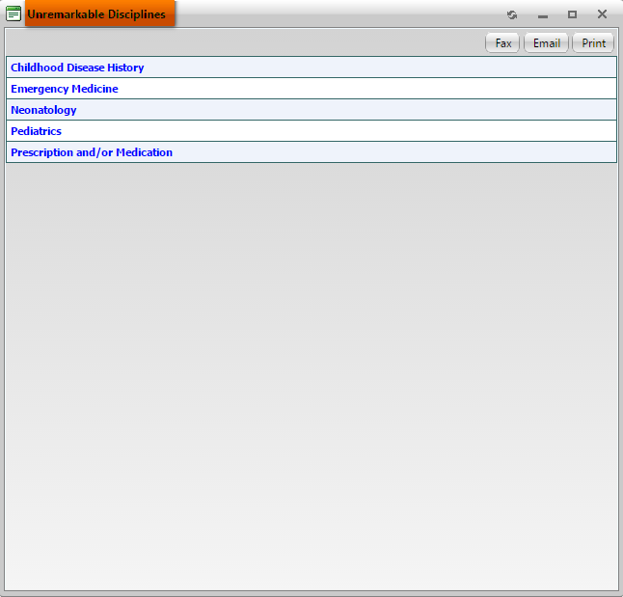

**(Image 13.1.3: Unremarkable Disciplines)**

**Note: Print, Fax and Email are same as 13.1.1.12, 13.1.1.13 and 13.1.1.14**

**13.1.4)****<http://umrtest.com/UMRPortals/PatientFeatures/MultiProviderListDetails.aspx?PatientKey=3&DispType=M>**

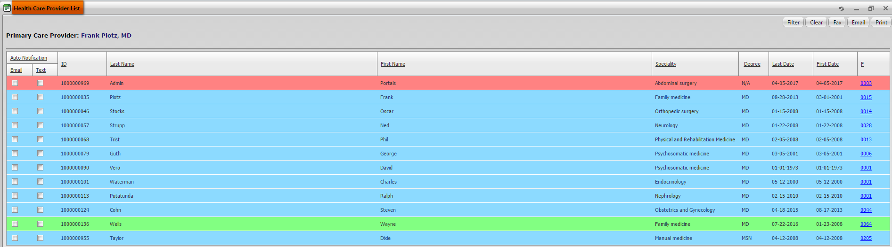

**(Image 13.1.4: Healthcare Providers)**

**NOTE: Filter, Clear, Fax, Email and Print buttons are related to Filter(Image 13.1.1.10), Clear(Image 13.1.1.11), Fax(Image 13.1.3.2), Email(Image 13.1.3.3), Print(Image 13.1.3.1), Service History(Image 13.1.2.2), Service List(Image 13.1.1.9 All).**

**13.1.5)****<http://umrtest.com/UMRPortals/PatientFeatures/AncilliaryHealthCareProviderList.aspx?PatientKey=3>**

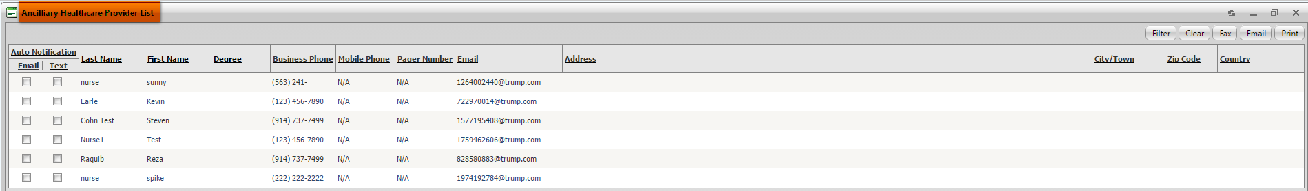

**(Image 13.1.5: Ancilliary Healthcare Providers)**

**NOTE: Filter, Fax, Email, Clear and Print links are related to Filter(Image 13.1.2.3), Fax(Image 13.1.3.2), Email(Image 13.1.3.3), Clear(Image 13.1.1.11) and Print(Image 13.1.3.1).**

***Back to index***

**13.1.6)** **<http://umrtest.com/UMRPortals/PatientFeatures/AssociatedAncProvList.aspx?PatientKey=3>**

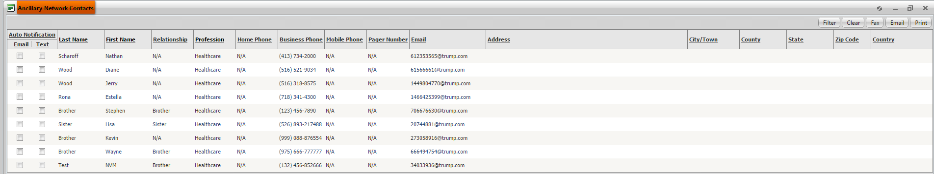

**(Image 13.1.6: Ancillary Network Contacts)**

**NOTE: Filter, Fax, Email, Clear and Print links are related to Filter(Image 13.1.2.3), Fax(Image 13.1.3.2), Email(Image 13.1.3.3), Clear(Image 13.1.1.11) and Print(Image 13.1.3.1).**

**13.1.7)** **<http://umrtest.com/UMRPortals/PatientFeatures/HealthcareFacilities.aspx?PatientKey=3>**

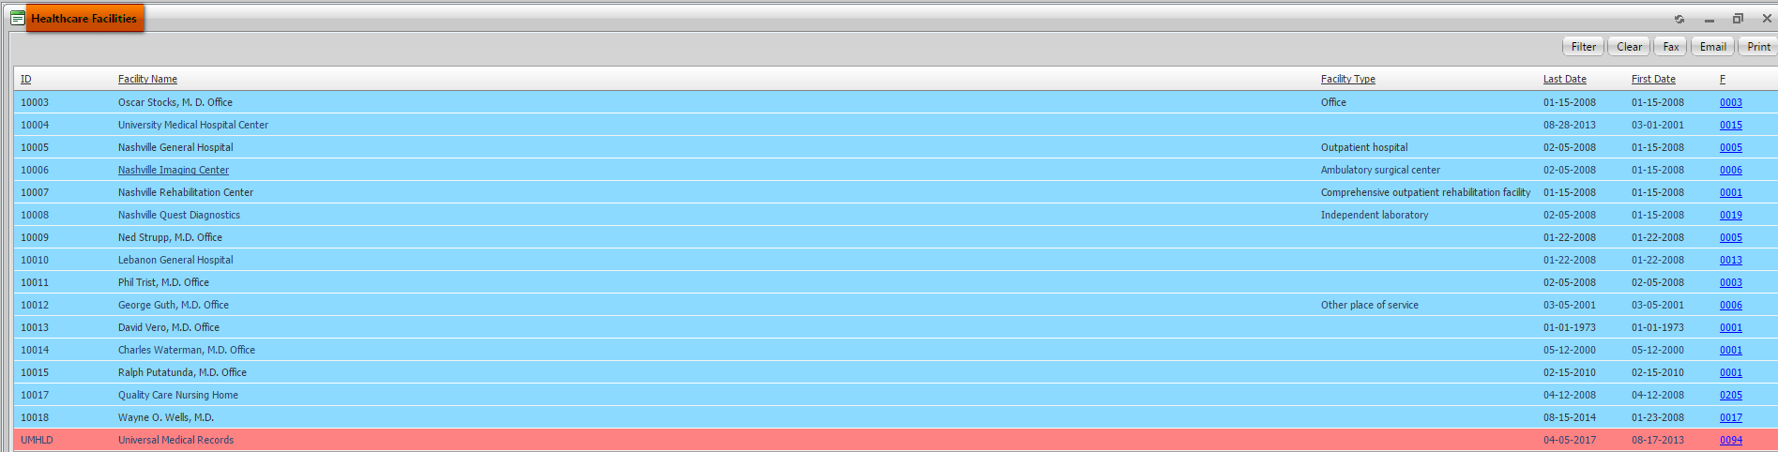

**(Image 13.1.7: Healthcare Facilities)**

**NOTE: Service History, Filter, Fax, Clear, Email and Print links are related to Service History(Image 13.1.2.2), Filter(Image 13.1.1.10), Fax(Image 13.1.3.2), Clear(Image 13.1.1.11), Email(Image 13.1.3.3) and Print(Image 13.1.3.1).**

**13.1.8)** **<http://umrtest.com/UMRPortals/PatientFeatures/AMD.aspx?PatientKey=3>**

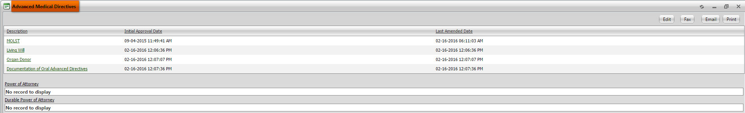

**(Image 13.1.8: Advanced Medical Directive)**

**NOTE: Fax, Email and Print links are related to Fax(Image 13.1.3.2), Email(Image 13.1.3.3) and Print(Image 13.1.3.1).**

**13.1.8.1)** **<http://umrtest.com/UMRPortals/DataRecord/Report/MOLSTReport.aspx?PatientKey=3>**

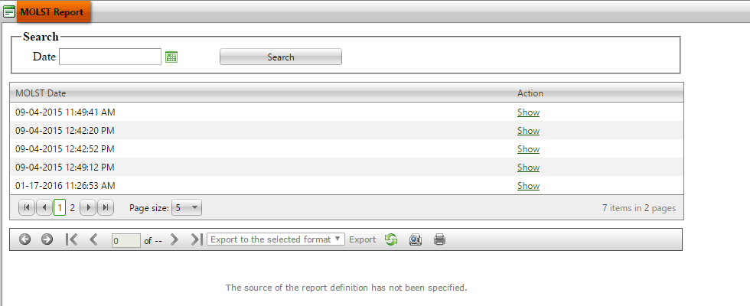

**(Image 13.1.8.1: MOLST Report)**

***Back to index***

**13.1.8.2)** **<http://umrtest.com/UMRPortals/DataRecord/Report/MOLSTReport.aspx?PatientKey=3>**

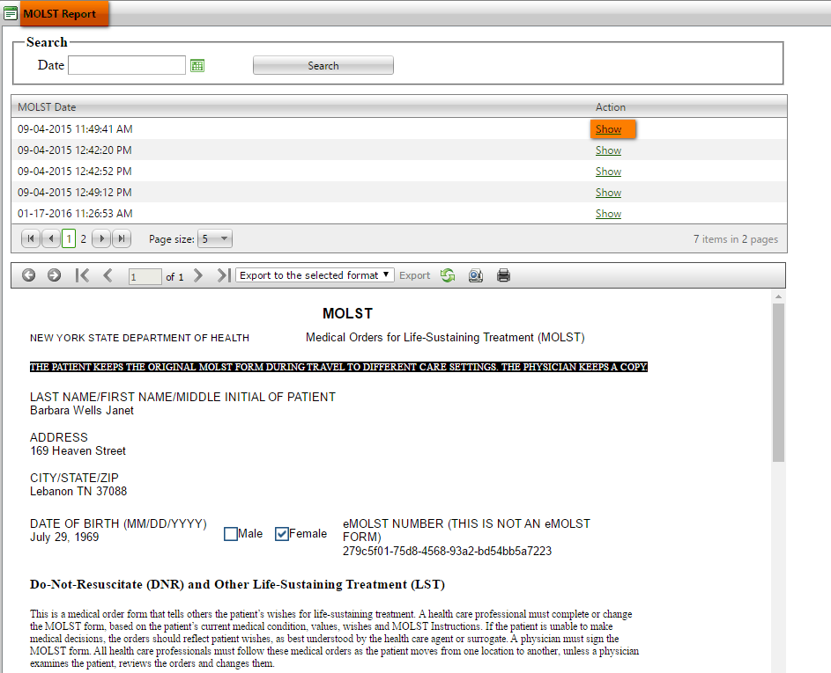

**(Image 13.1.8.2: MOLST Report - Show)**

**13.1.8.3)** [**h****ttp://umrtest.com/UMRPortals/PatientFeatures/AMDEditor.aspx?PatientKey=3**](http://umrtest.com/UMRPortals/PatientFeatures/AMDEditor.aspx?PatientKey=3)

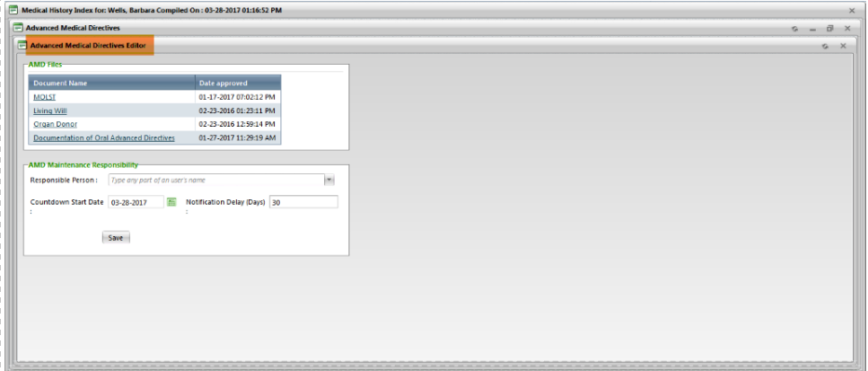

**(Image 13.1.8.3: Advanced Medical Directive Editor)**

***Back to index***

**13.1.8.4)** **<http://umrtest.com/UMRPortals/DataRecord/PatientMOLSTViewer.aspx?PatientKey=3>**

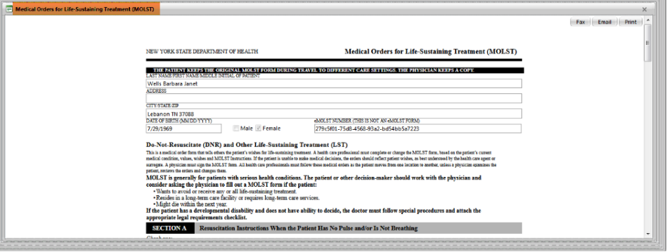

**(Image 13.1.8.4: MOLST)**

**13.1.9)** **<http://umrtest.com/UMRPortals/PatientFeatures/Emergency.aspx?PatientKey=3>**



**(Image 13.1.9: Emergency Information)**

**NOTE: Filter, Fax, Clear, Email and Print links are related to Filter(Image 13.1.2.3), Fax(Image 13.1.3.2), Clear(Image 13.1.1.11), Email(Image 13.1.3.3) and Print(Image 13.1.3.1).**

**13.1.10)** **<http://umrtest.com/UMRPortals/AlertNetwork/AlertChronologyList.aspx?PatientKey=3>**

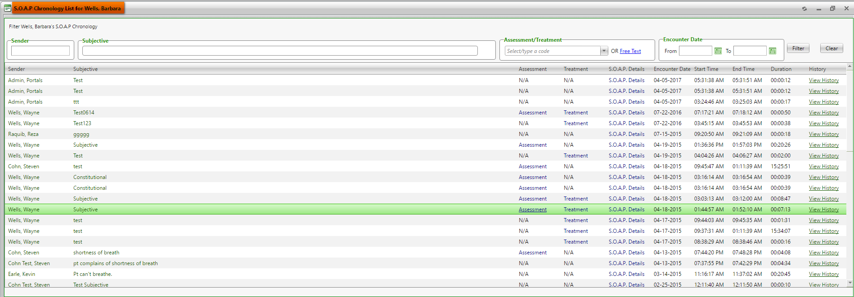

**(Image 13.1.10: SOAP Chronology)**

**13.1.10.1)****<http://umrtest.com/UMRPortals/AlertNetwork/ViewAssessmentDetails.aspx?AlertId=171058>**

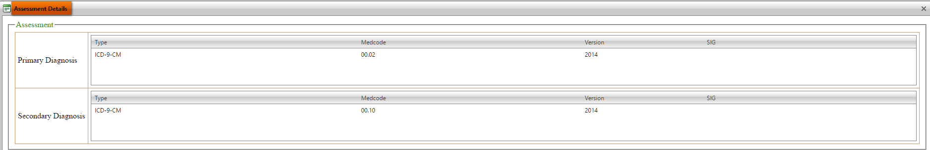

**(Image 13.1.10.1: Assessment Details)**

***Back to index***

**13.1.10.2)****<http://umrtest.com/UMRPortals/AlertNetwork/ViewTreatmentDetails.aspx?AlertId=171058>**

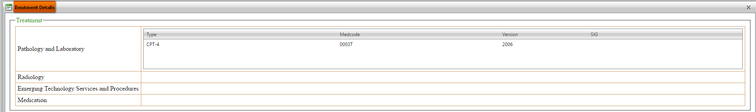

**(Image 13.1.10.2: Treatment Details)**

**13.1.10.3)** **<http://umrtest.com/UMRPortals/AlertNetwork/AlertHistory.aspx?AlertId=171058>**

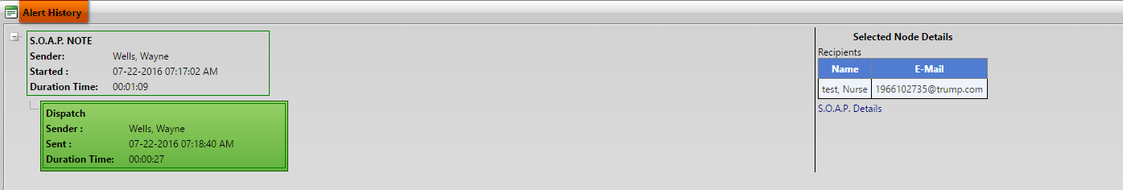

**(Image 13.1.10.3: Alert History)**

**13.1.11)** **<http://umrtest.com/UMRPortals/PatientFeatures/Demographic.aspx?PatientKey=3>**

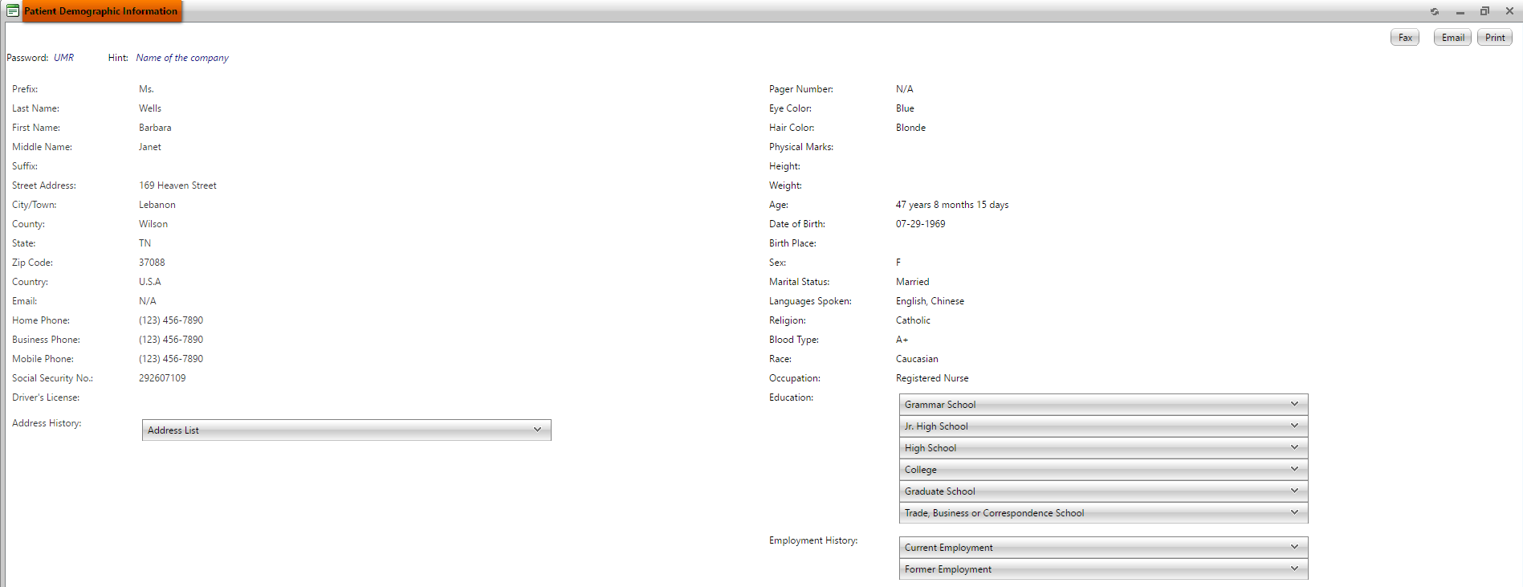

**(Image 13.1.11: Patient Demographics Information)**

**NOTE: Fax, Email and Print links are related to Fax(Image 13.1.3.2), Email(Image 13.1.3.3) and Print(Image 13.1.3.1).**

**13.1.12)** **<http://umrtest.com/UMRPortals/PatientFeatures/Insurance.aspx?PatientKey=3>**

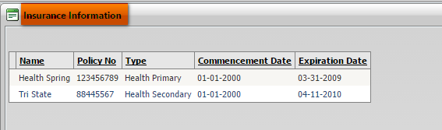

**(Image 13.1.12: Insurance Information)**

**NOTE: Fax, Email and Print links are related to Fax(Image 13.1.3.2), Email(Image 13.1.3.3) and Print(Image 13.1.3.1).**

***Back to index***

**13.1.13)** [**http://umrtest.com/UMRPortals/PatientFeatures/PatientSchedule.aspx?PatientKey=3**](http://umrtest.com/UMRPortals/PatientFeatures/PatientSchedule.aspx?PatientKey=3)

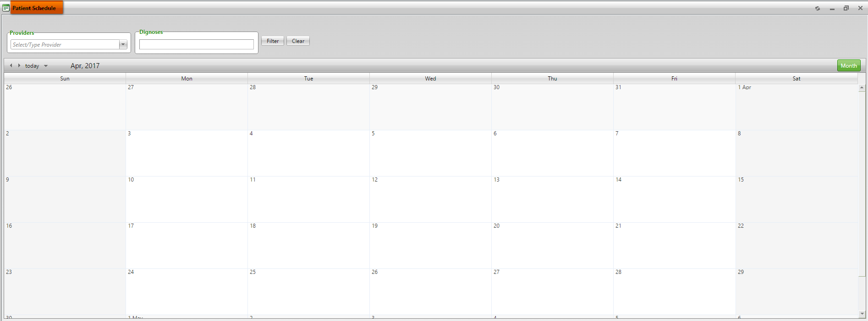

**(Image 13.1.13: Patient Schedule)**

**13.1.14)** **<http://umrtest.com/UMRPortals/PatientFeatures/Legend.aspx?PatientKey=3>**

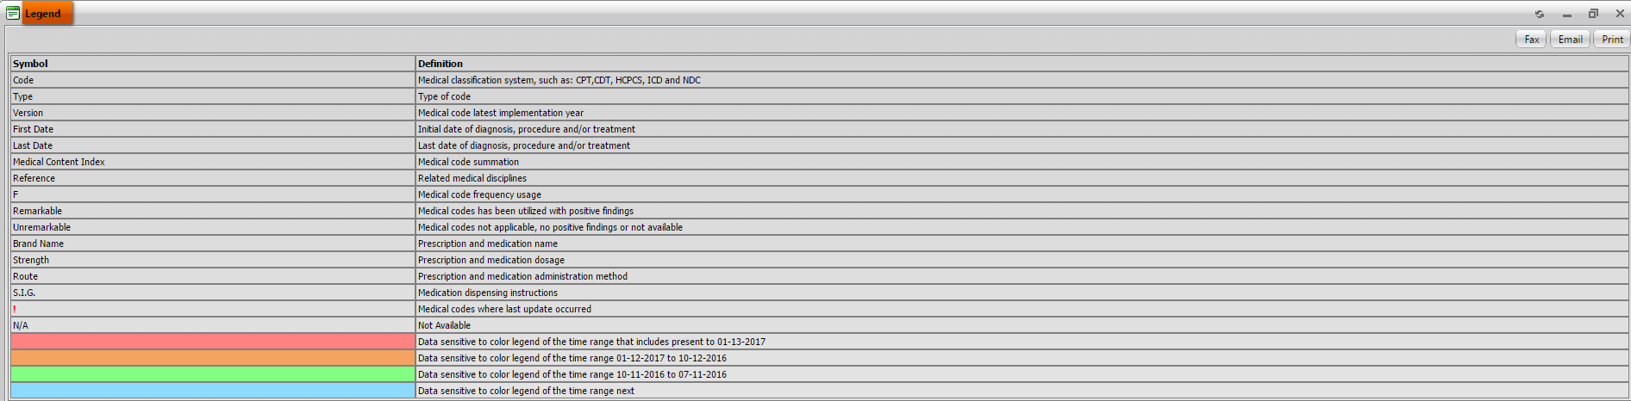

**(Image 13.1.14: Legend)**

**NOTE: Fax, Email and Print links are related to Fax(Image 13.1.3.2), Email(Image 13.1.3.3) and Print(Image 13.1.3.1).**

**13.1.15)** **<http://umrtest.com/UMRPortals/PatientFeatures/Disclaimer.aspx>**



**(Image 13.1.15: Disclaimer)**

**13.1.16)****<http://umrtest.com/UMRPortals/PatientFeatures/RDNew.aspx?PatientKey=3&DisCode=9&DisType=D&DisName=Gastroenterology&CodeType=(CODE_TYPE=@1@%20OR%20CODE_TYPE=@2@%20OR%20CODE_TYPE=@3@%20OR%20CODE_TYPE=@5@)>**



**(Image 13.1.16: Remarkable Disciplines)**

**NOTE: Medcode History, Related Disciplines, Diagnosis Details, Filter, Clear, Fax, Email and Print links are related to Medcode History(Image 13.1.1.1), Related Disciplines(Image 13.1.1.2), Diagnosis Details(Image 13.1.1.3), Filter(Image 13.1.1.10), Clear(Image 13.1.1.11), Fax(Image 13.1.3.2), Email(Image 13.1.3.3) and Print(Image 13.1.3.1).**

***Back to index***

**13.1.17)****<http://umrtest.com/UMRPortals/PatientFeatures/PrintPreview.aspx?PatientKey=3&SelectedCodeIndex=0,1,2,4>**

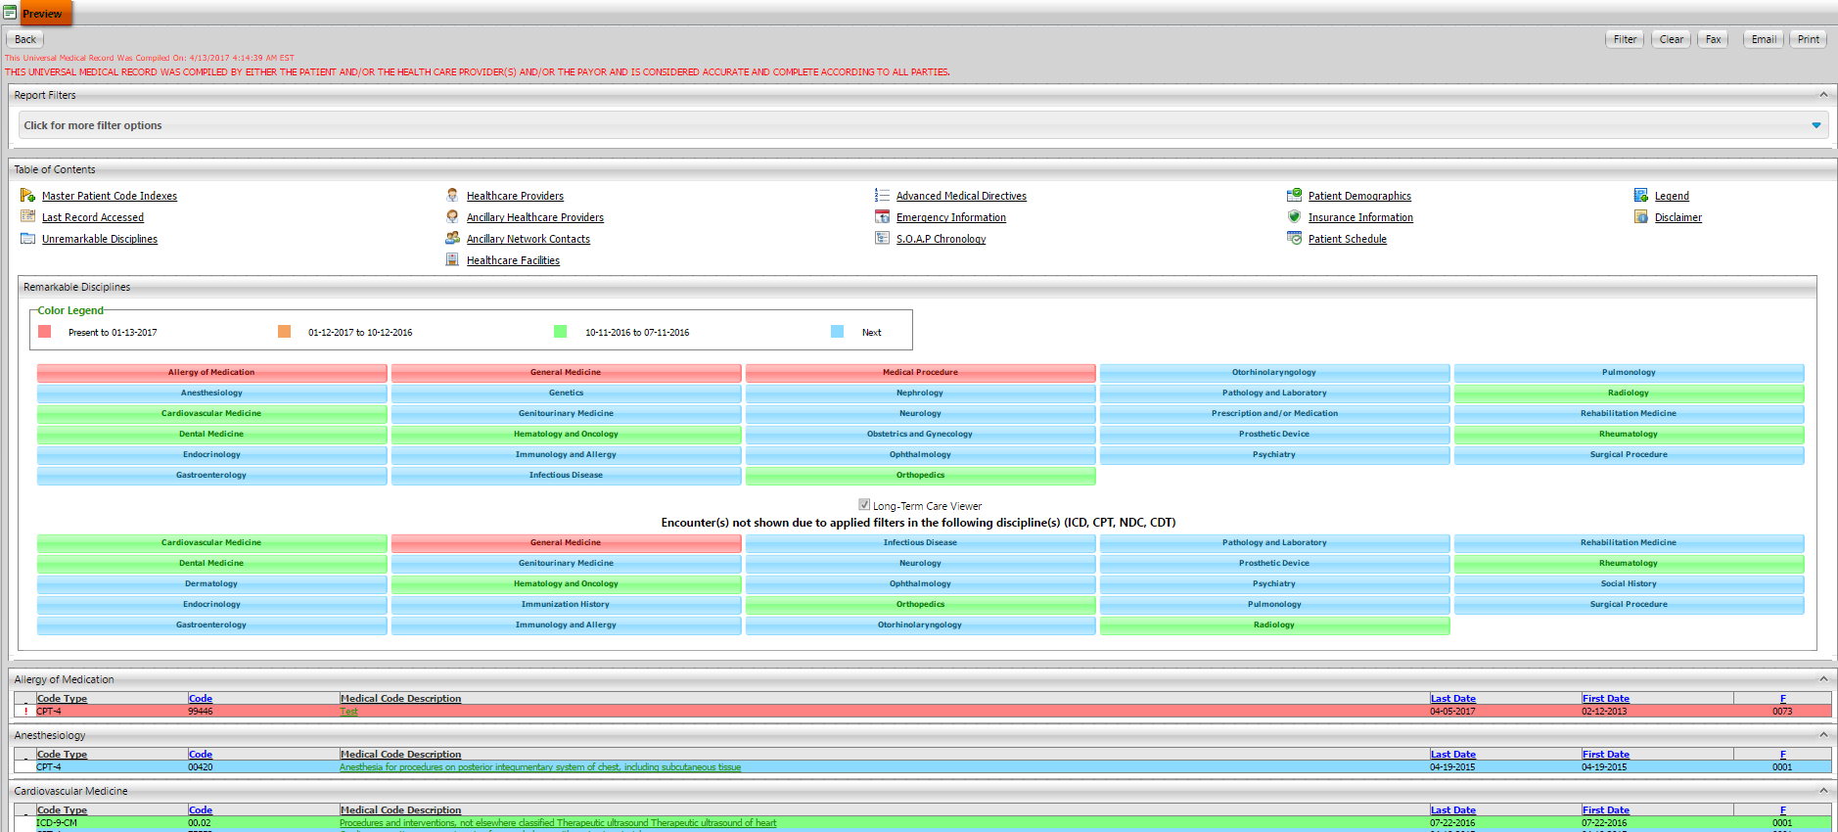

**(Image 13.1.17: Preview)**

**13.2)****<http://umrtest.com/UMRPortals/PatientFeatures/SOAPSelectionWindow.aspx?UserId=10967&PatientKey=3&LastIncompleteStatus=false>**

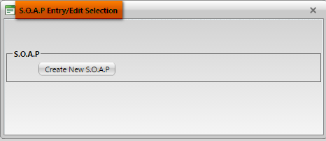

**(Image 13.2: SOAP Entry/Edit Selection-1)**

**13.2.1)** **<http://umrtest.com/UMRPortals/AlertNetwork/ProviderNotesPop.aspx?PatientKey=3>**

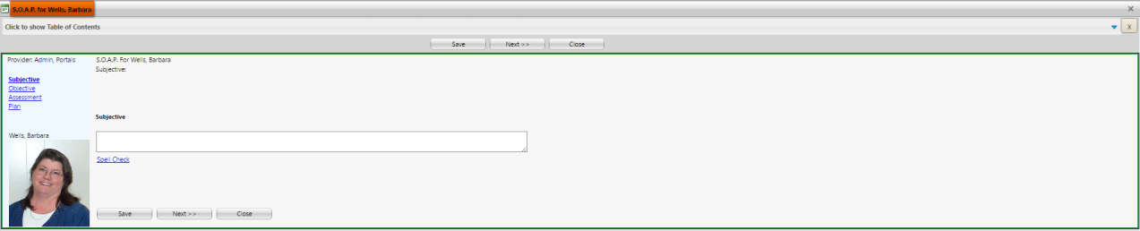

**(Image 13.2.1: SOAP Entry/Edit Selection-2)**

***Back to index***

**13.2.2)** **<http://umrtest.com/UMRPortals/AlertNetwork/ProviderNotesPop.aspx?AlertIdToEdit=171065>**

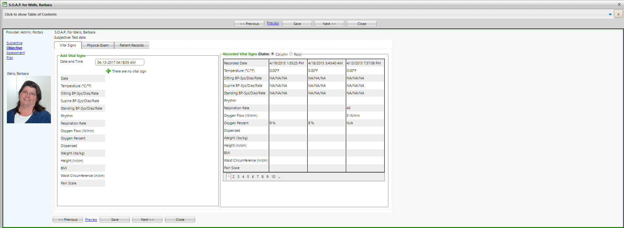

**(Image 13.2.2: SOAP Entry/Edit Selection-3)**

**13.2.3)** **<http://umrtest.com/UMRPortals/AlertNetwork/ProviderNotesPop.aspx?AlertIdToEdit=171065>**

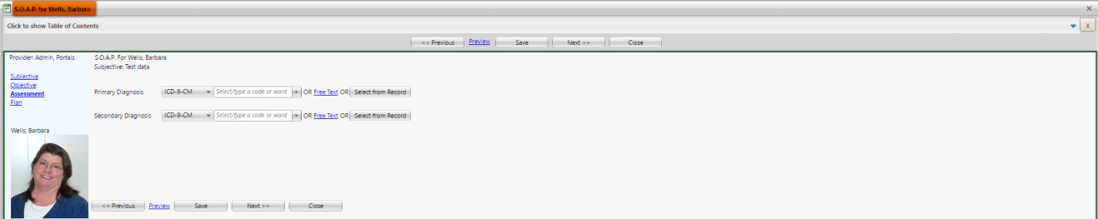

**(Image 13.2.3: SOAP Entry/Edit Selection-4)**

**13.2.4)** **<http://umrtest.com/UMRPortals/AlertNetwork/ProviderNotesPop.aspx?AlertIdToEdit=171065>**

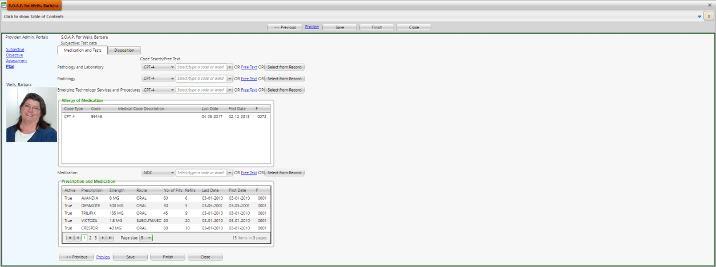

**(Image 13.2.4: SOAP Entry/Edit Selection-5)**

***Back to index***

**13.2.5)** **<http://umrtest.com/UMRPortals/AlertNetwork/ProviderNotesPop.aspx?AlertIdToEdit=171065>**

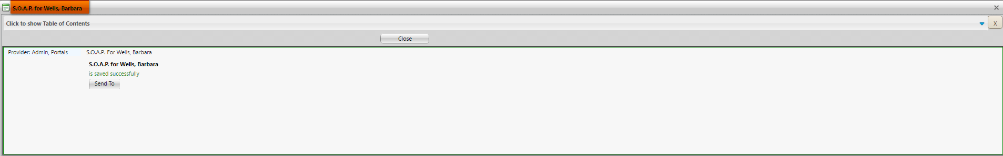

**(Image 13.2.5: SOAP Entry/Edit Selection-6)**

**13.2.6)** **<http://umrtest.com/UMRPortals/AlertNetwork/ProviderNotesPop.aspx?AlertIdToEdit=171065>**

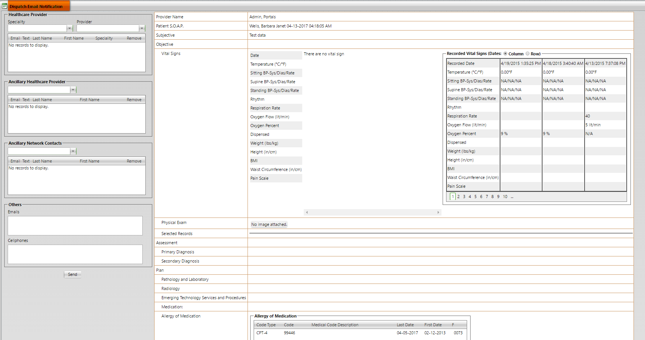

**(Image 13.2.6: SOAP Entry/Edit Selection-7)**

1. **<http://umrtest.com/UMRPortals/PatientFeatures/PatientFeatures.aspx>**

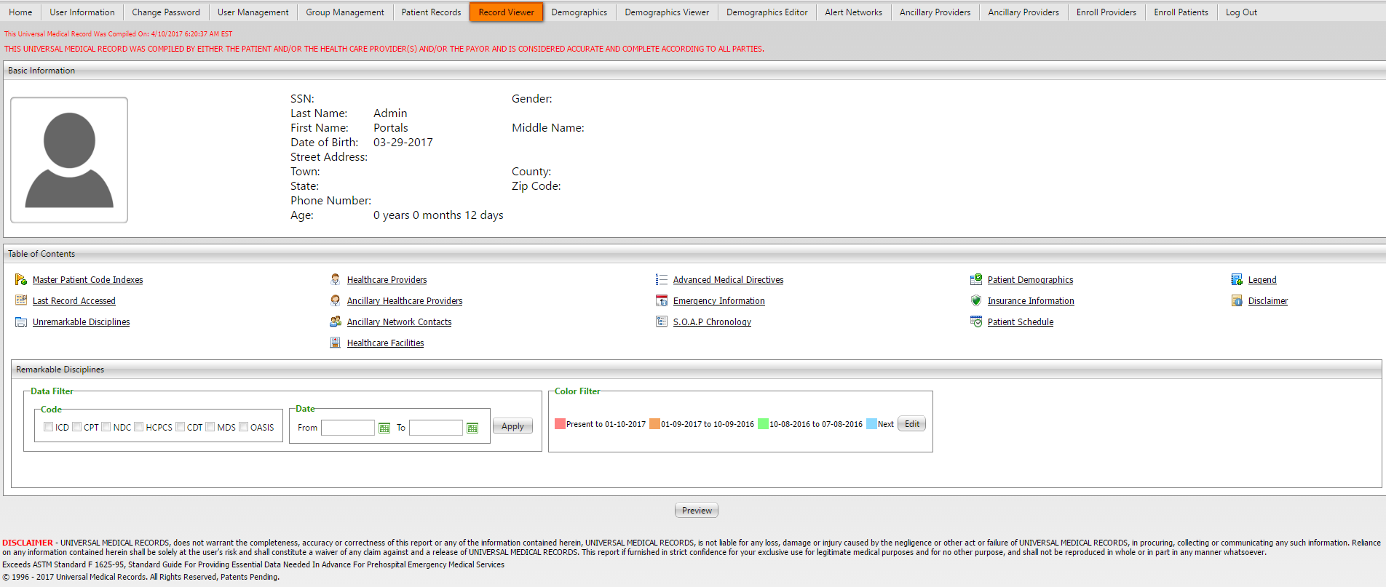

**(Image 14: Record Viewer)**

***Back to index***

1. **<http://umrtest.com/UMRPortals/DataRecord/PatientDemographics.aspx>**

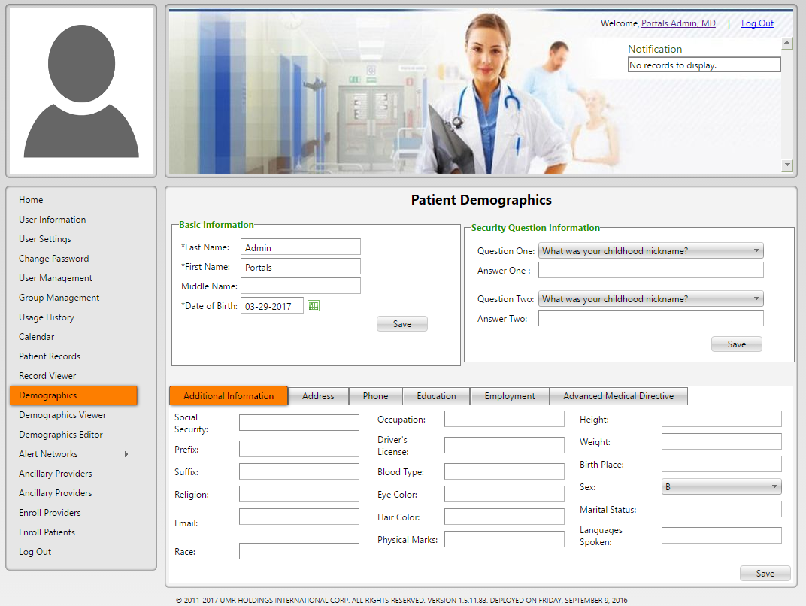

**(Image 15: Demographics Additional Information)**

**15.1)** **<http://umrtest.com/UMRPortals/DataRecord/PatientDemographics.aspx>**

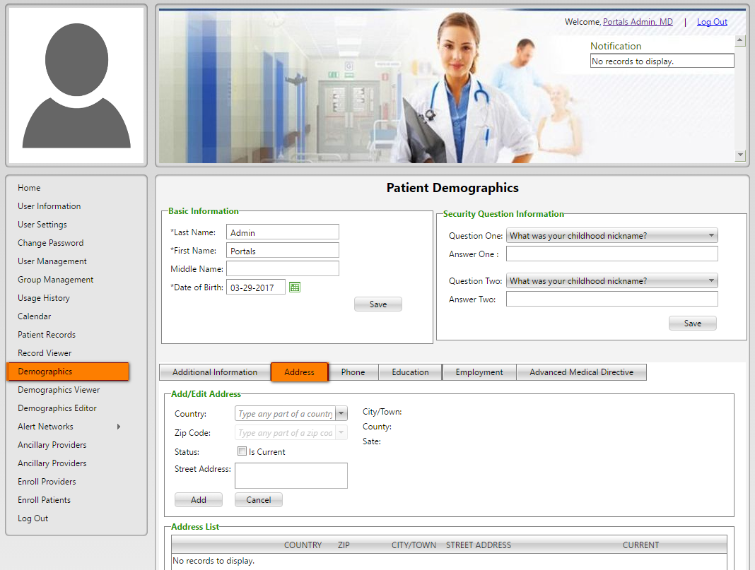

**(Image 15.1: Demographics >> Address)**

***Back to index***

**15.2)** **<http://umrtest.com/UMRPortals/DataRecord/PatientDemographics.aspx>**

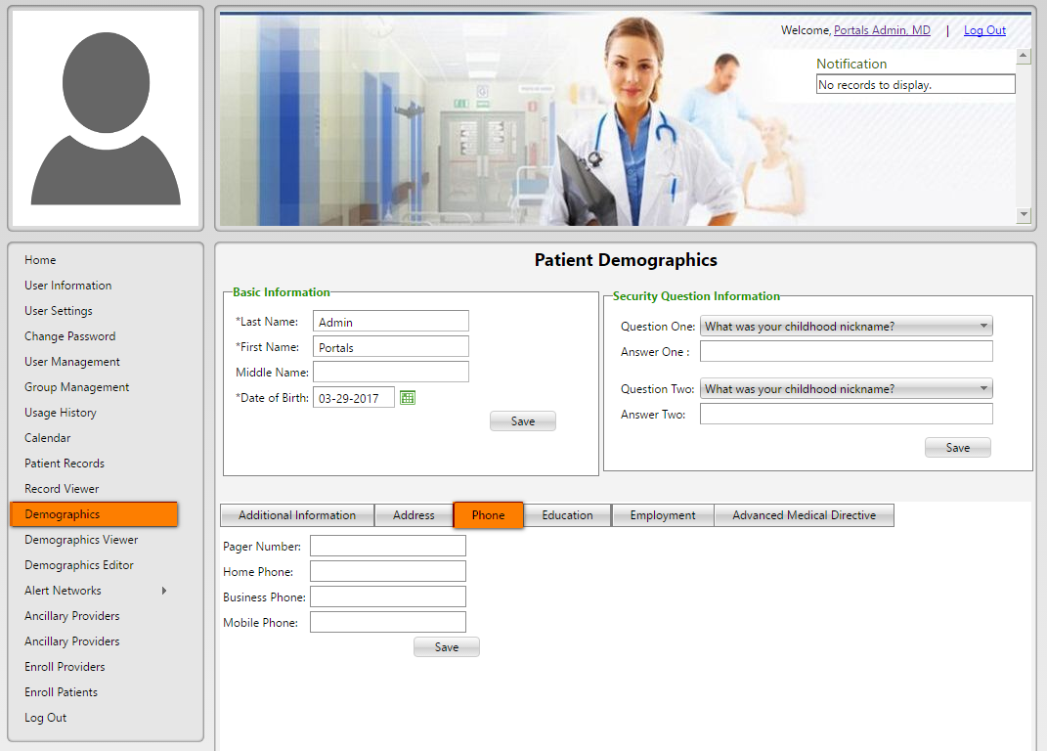

**(Image 15.2: Demographics >> Phone)**

**15.3)** **<http://umrtest.com/UMRPortals/DataRecord/PatientDemographics.aspx>**

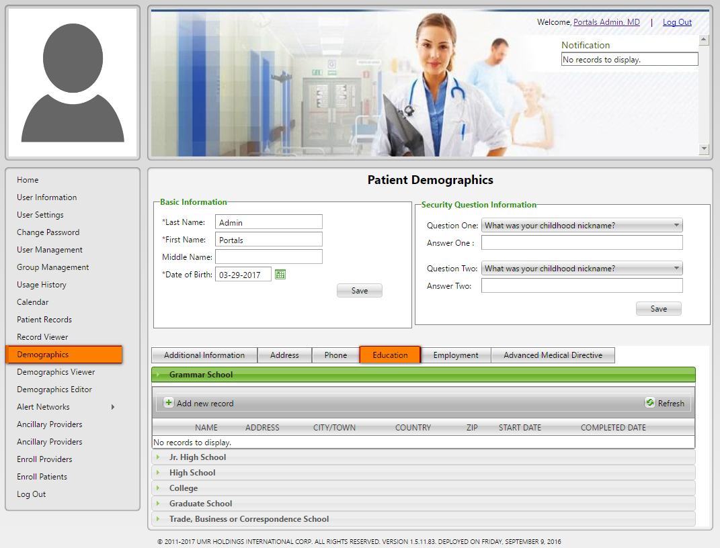

**(Image 15.3: Demographics >> Education)**

***Back to index***

**15.4)** **<http://umrtest.com/UMRPortals/DataRecord/PatientDemographics.aspx>**

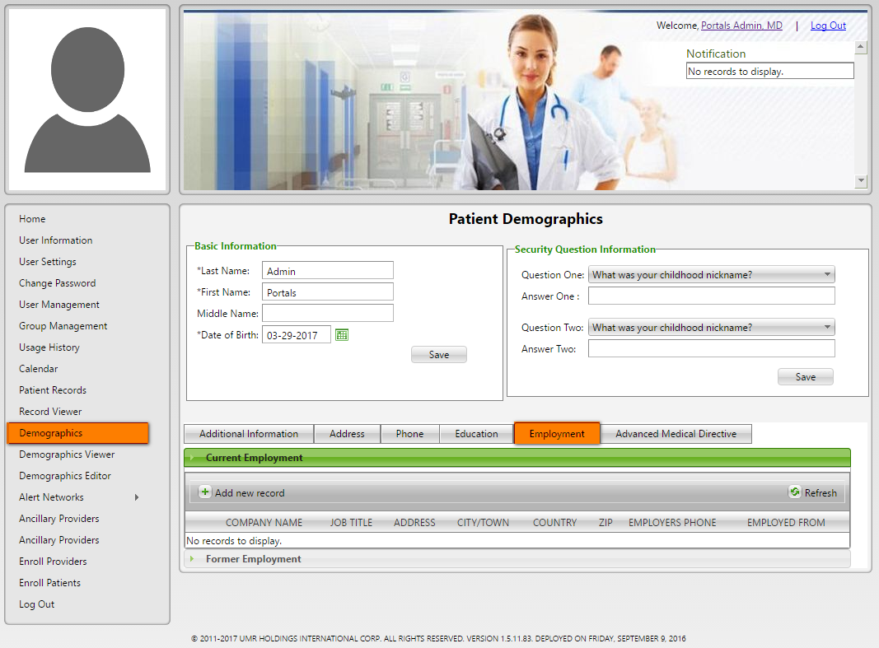

**Image 15.4: Demographics >> Employment)**

**15.5)** **<http://umrtest.com/UMRPortals/DataRecord/PatientDemographics.aspx>**

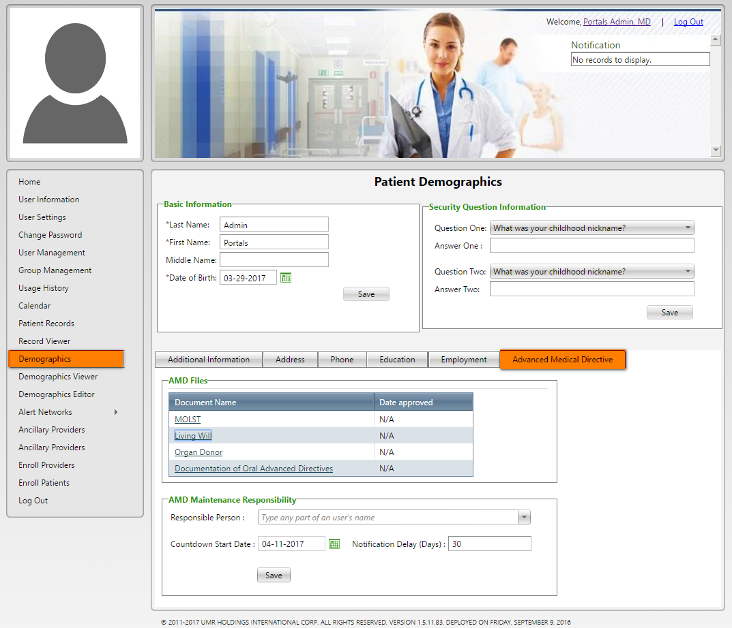

**Image 15.5: Demographics >> Advanced Medical Directive)**

***Back to index***

1. **<http://umrtest.com/UMRPortals/DataRecord/DemographicsViewer.aspx>**

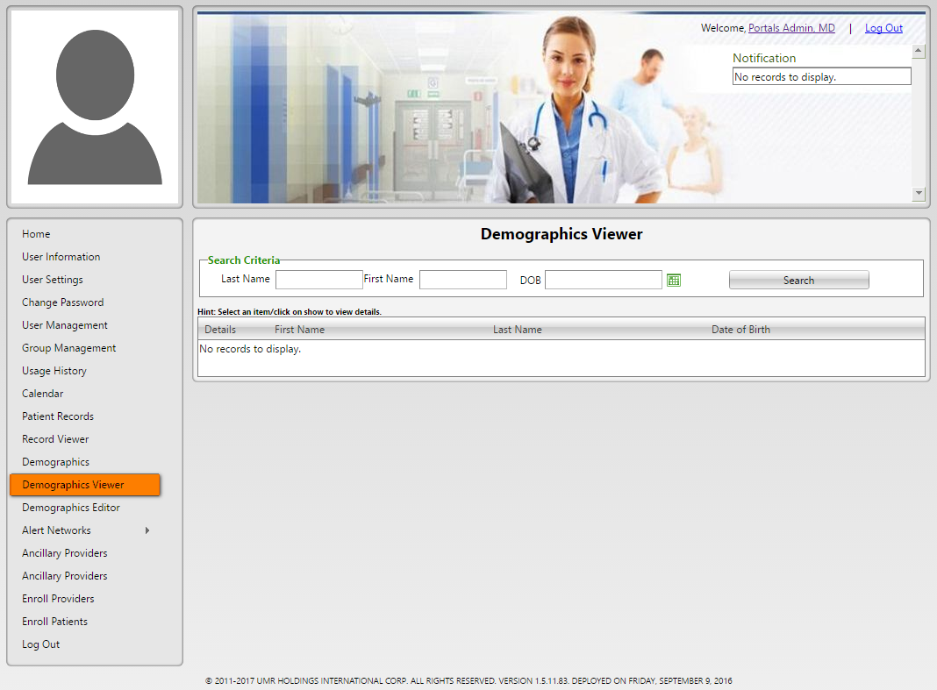

**(Image 16: Demographics Viewer)**

**16.1)** **<http://umrtest.com/UMRPortals/DataRecord/DemographicsViewer.aspx>**

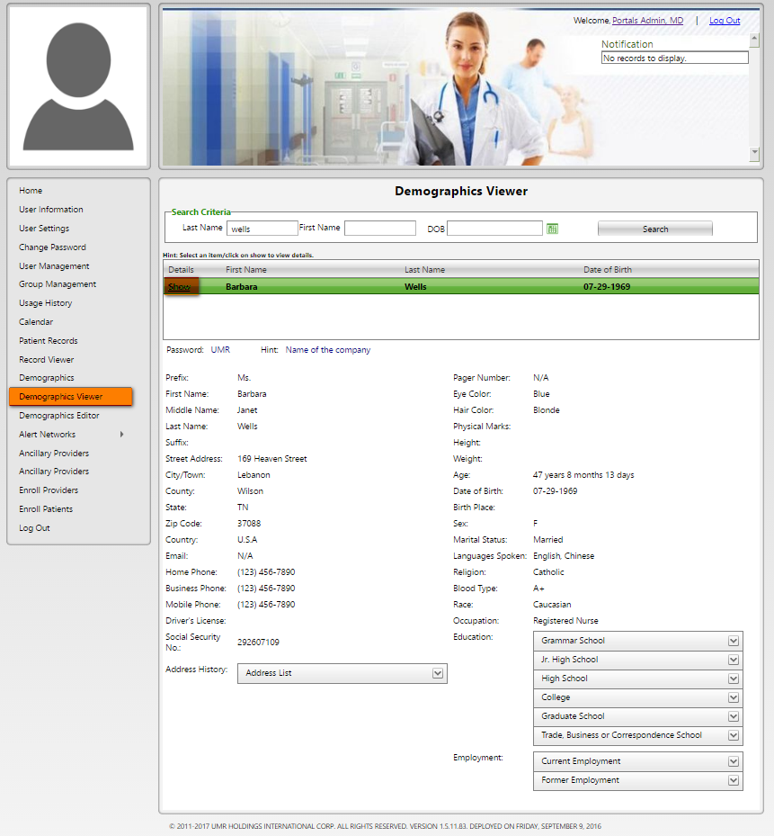

**(Image 16.1: Demographics Viewer >> Show)**

***Back to index***

1. **<http://umrtest.com/UMRPortals/DataRecord/DemographicsEditor.aspx>**

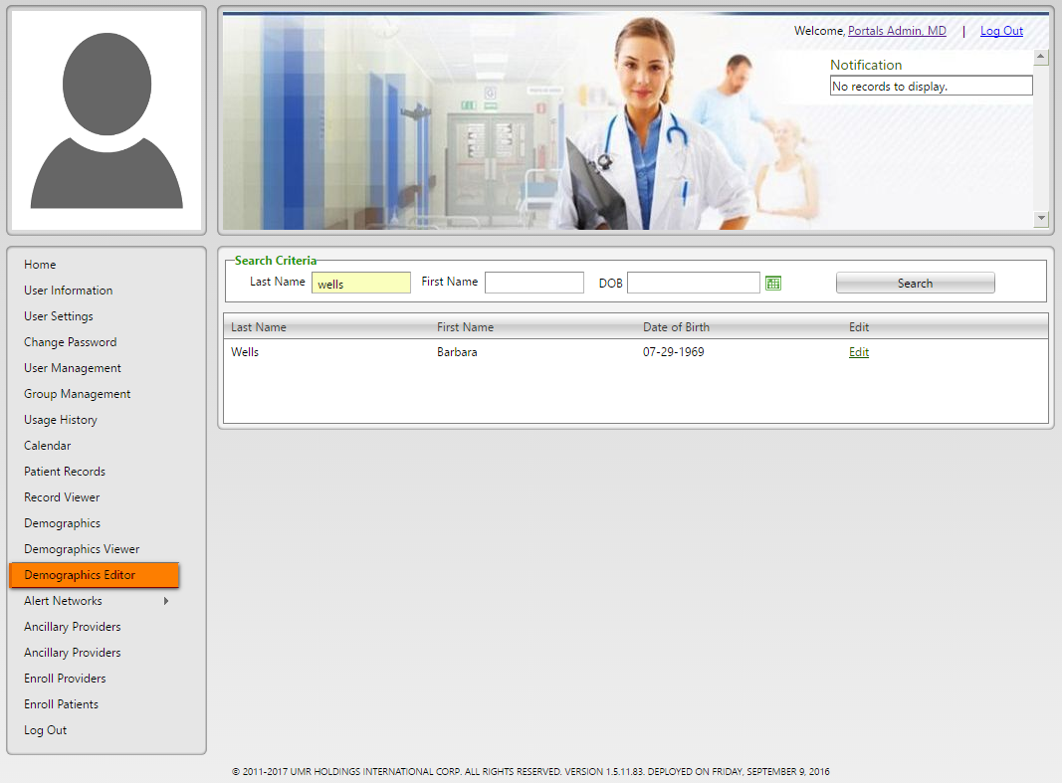

**(Image 17: Demographics Editor)**

**17.1)** **<http://umrtest.com/UMRPortals/DataRecord/PatientDemographicsPop.aspx?PatientKey=3>**

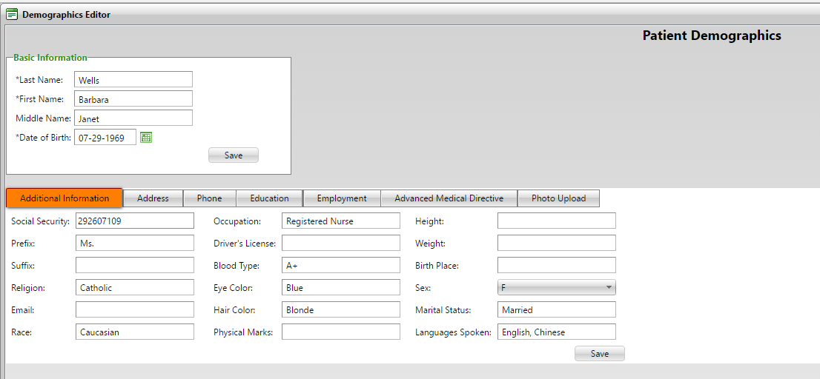

**(Image 17.1: Demographics Editor >> Additional Information)**

***Back to index***

**17.2)** **<http://umrtest.com/UMRPortals/DataRecord/PatientDemographicsPop.aspx?PatientKey=3>**

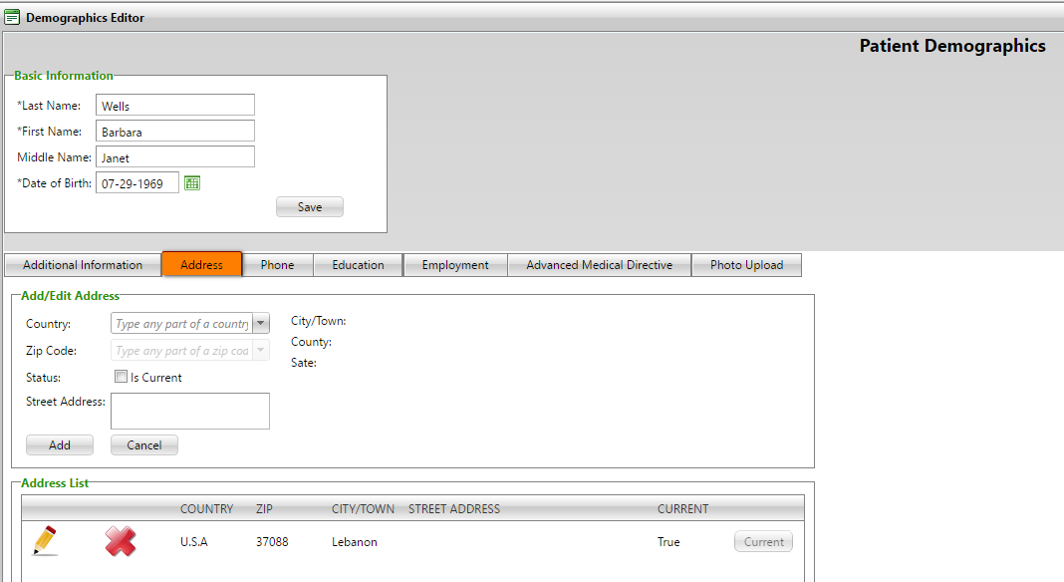

**(Image 17.2: Demographics Editor >> Address)**

**17.3)** **<http://umrtest.com/UMRPortals/DataRecord/PatientDemographicsPop.aspx?PatientKey=3>**

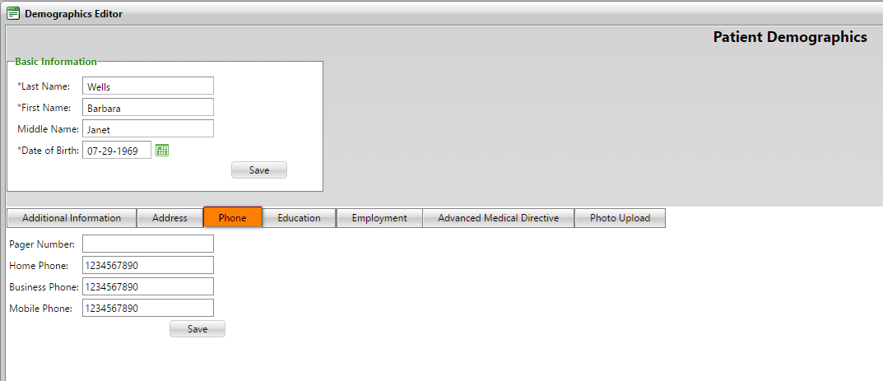

**(Image 17.3: Demographics Editor >> Phone)**

**17.4)** **<http://umrtest.com/UMRPortals/DataRecord/PatientDemographicsPop.aspx?PatientKey=3>**

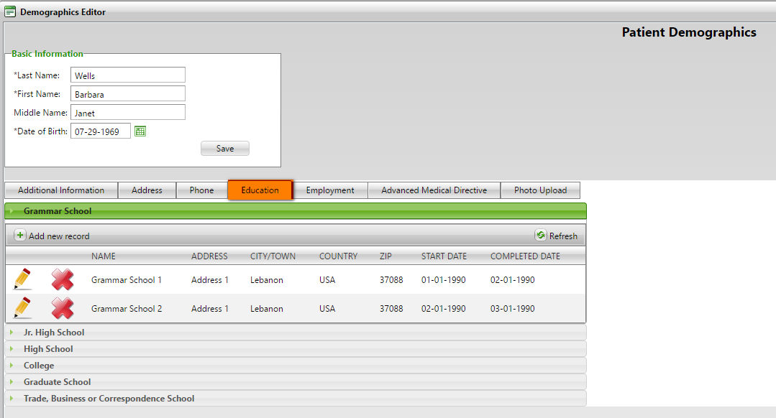

**(Image 17.4: Demographics Editor >> Education)**

***Back to index***

**17.5)** **<http://umrtest.com/UMRPortals/DataRecord/PatientDemographicsPop.aspx?PatientKey=3>**

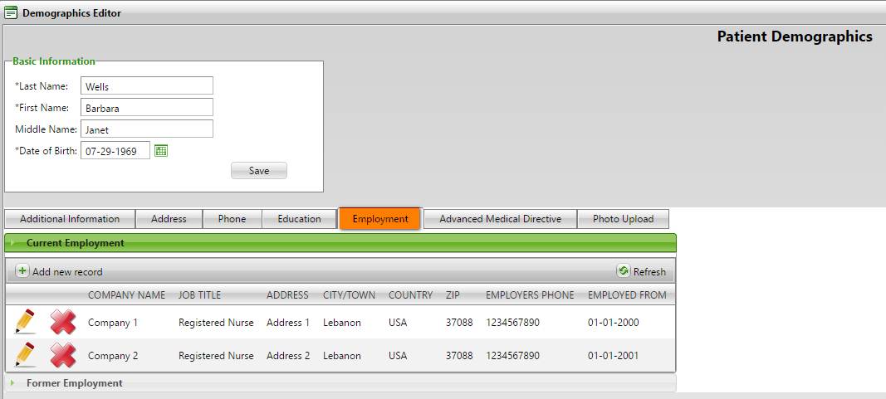

**(Image 17.5: Demographics Editor >> Employment)**

**17.6)** **<http://umrtest.com/UMRPortals/DataRecord/PatientDemographicsPop.aspx?PatientKey=3>**

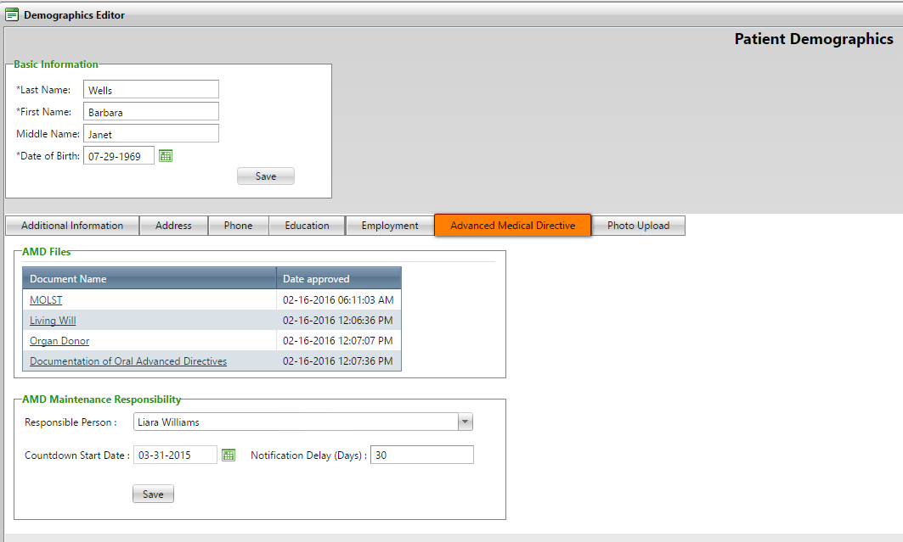

**(Image 17.6: Demographics Editor >> Advanced Medical Directive)**

**17.7)** **<http://umrtest.com/UMRPortals/DataRecord/PatientDemographicsPop.aspx?PatientKey=3>**

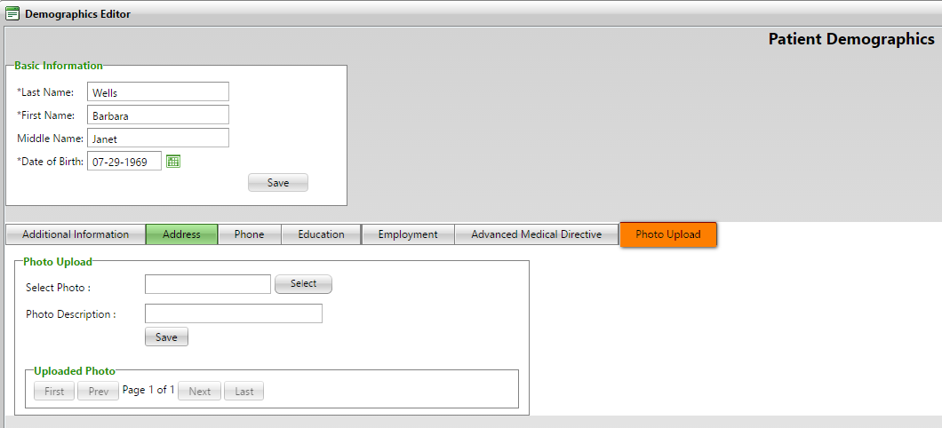

**(Image 17.7: Demographics Editor >> Photo Upload)**

***Back to index***

1. **<http://umrtest.com/UMRPortals/AlertNetwork/ProviderNotes.aspx>**

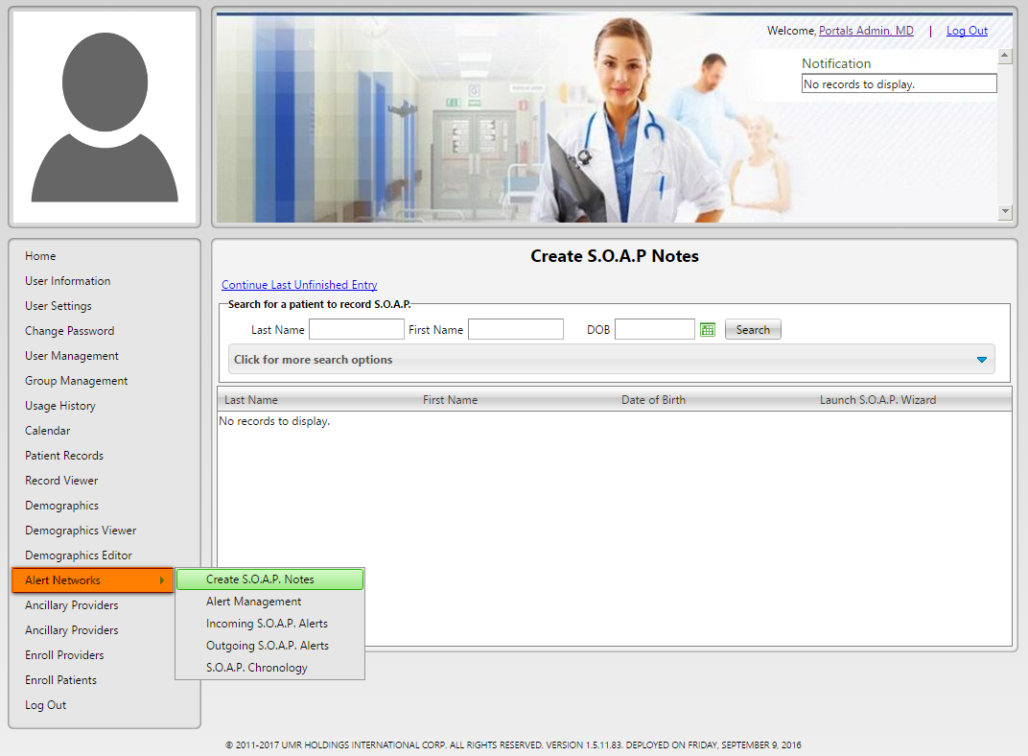

**(Image 18: Alert Network >> Create SOAP Notes)**

**18.1)** **<http://umrtest.com/UMRPortals/AlertNetwork/AlertNetworkManagement.aspx>**

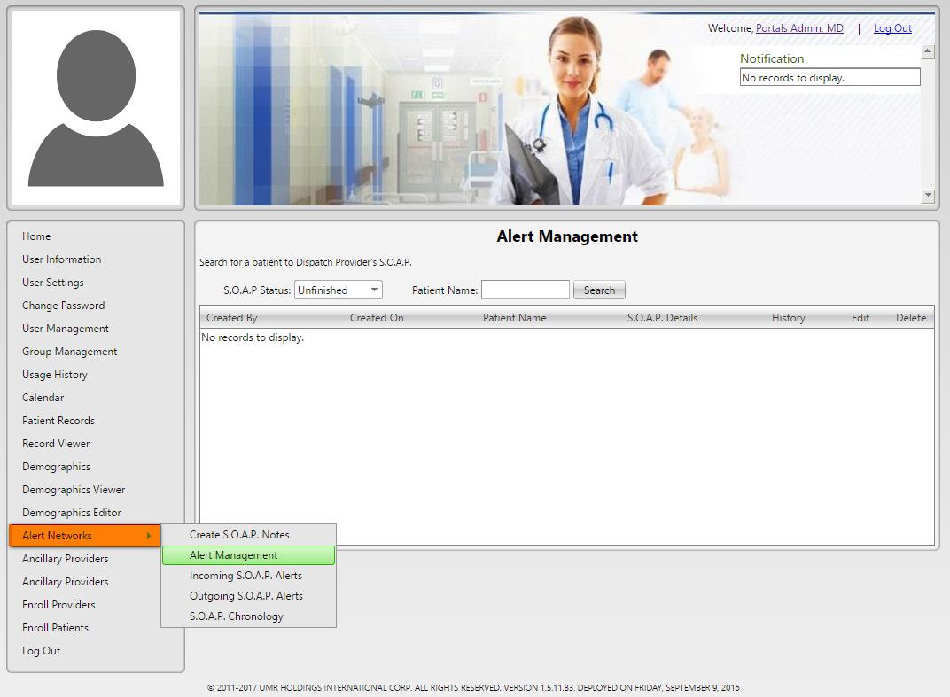

**(Image 18.1: Alert Network >> Alert Management)**

***Back to index***

**18.1.1)** **<http://umrtest.com/UMRPortals/AlertNetwork/AlertNetworkManagement.aspx>**

[**http://umrtest.com/UMRPortals/AlertNetwork/ViewProviderSoap.aspx?AlertId=171063**](http://umrtest.com/UMRPortals/AlertNetwork/ViewProviderSoap.aspx?AlertId=171063)

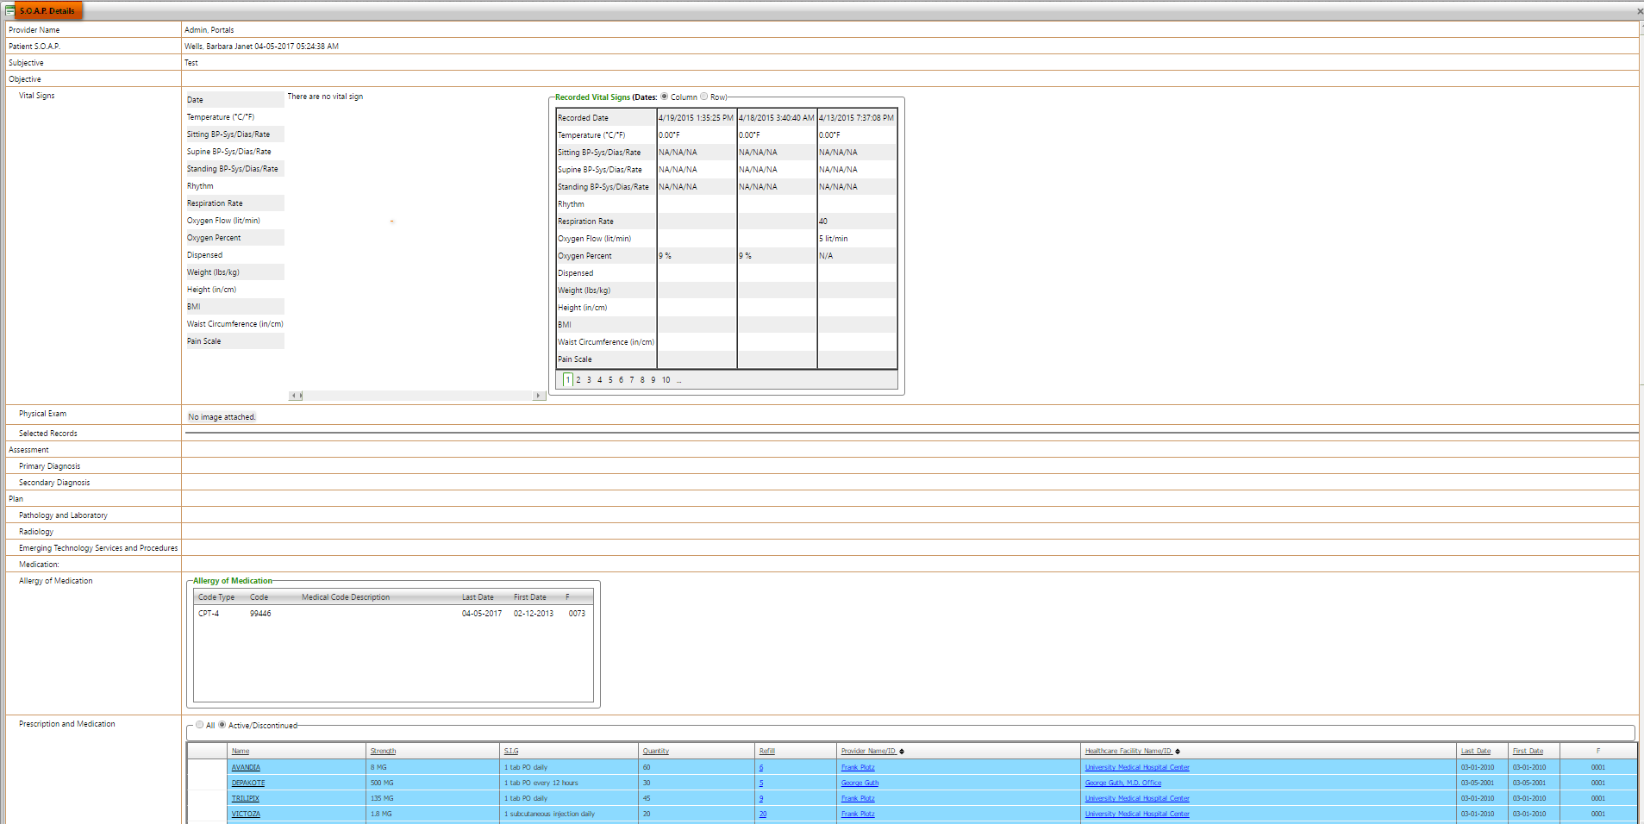

**(Image 18.1.1: Alert Management >> SOAP Details)**

**18.1.2)** **<http://umrtest.com/UMRPortals/AlertNetwork/AlertNetworkManagement.aspx>**

[**http://umrtest.com/UMRPortals/AlertNetwork/AlertHistory.aspx?AlertId=171063**](http://umrtest.com/UMRPortals/AlertNetwork/AlertHistory.aspx?AlertId=171063)

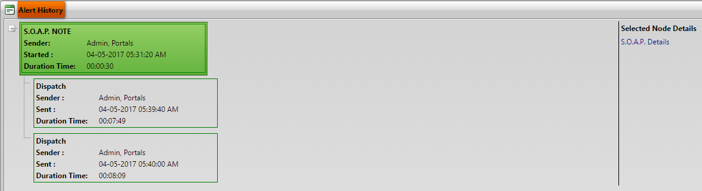

**(Image 18.1.2: Alert Management >> Alert History)**

**18.1.3)** **<http://umrtest.com/UMRPortals/AlertNetwork/AlertNetworkManagement.aspx>**

**<http://umrtest.com/UMRPortals/AlertNetwork/Dispatcher.aspx?AlertId=171067>**

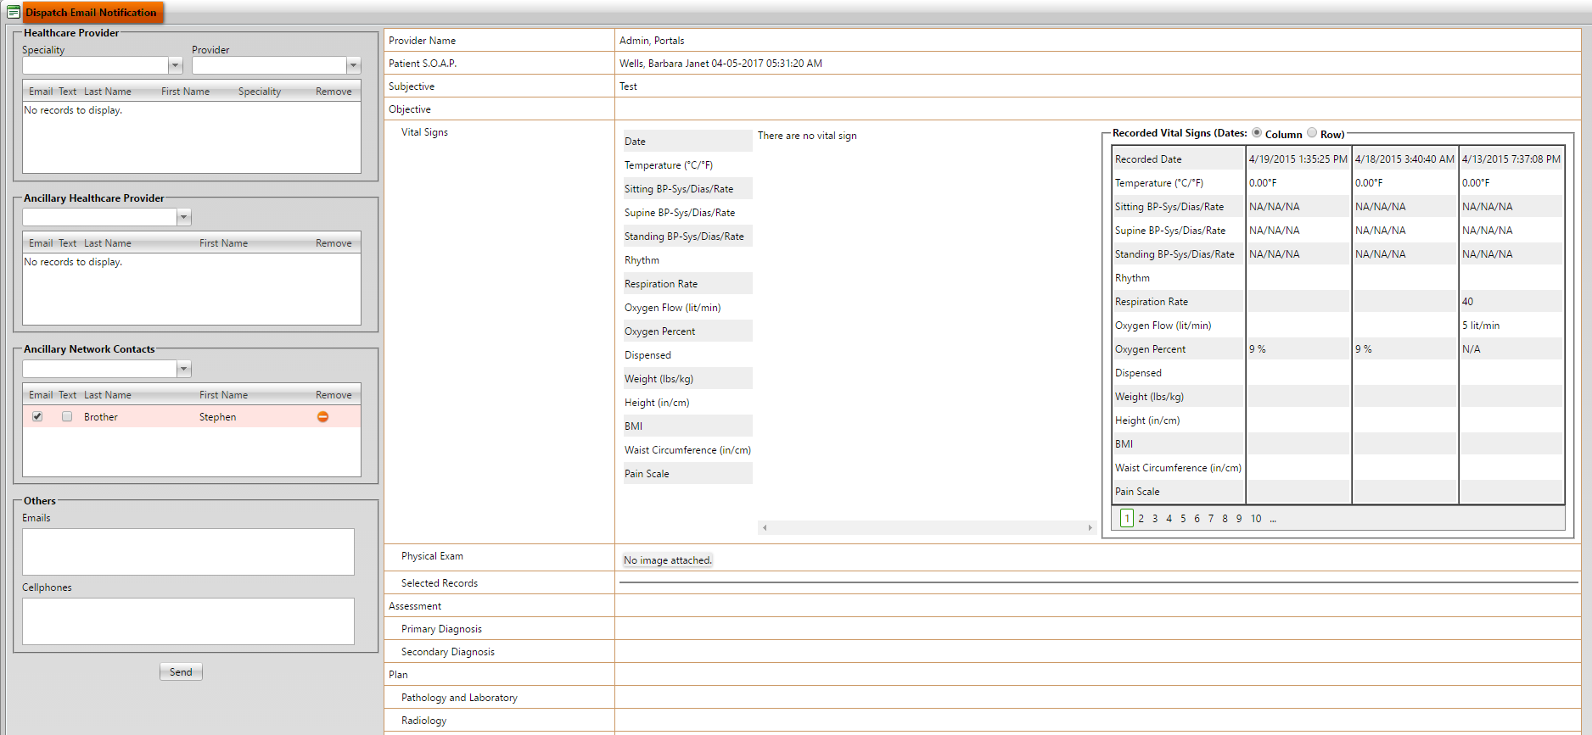

**(Image 18.1.3: Alert Management >> Send To)**

***Back to index***

**18.2)** **<http://umrtest.com/UMRPortals/AlertNetwork/IncomingAlert.aspx>**

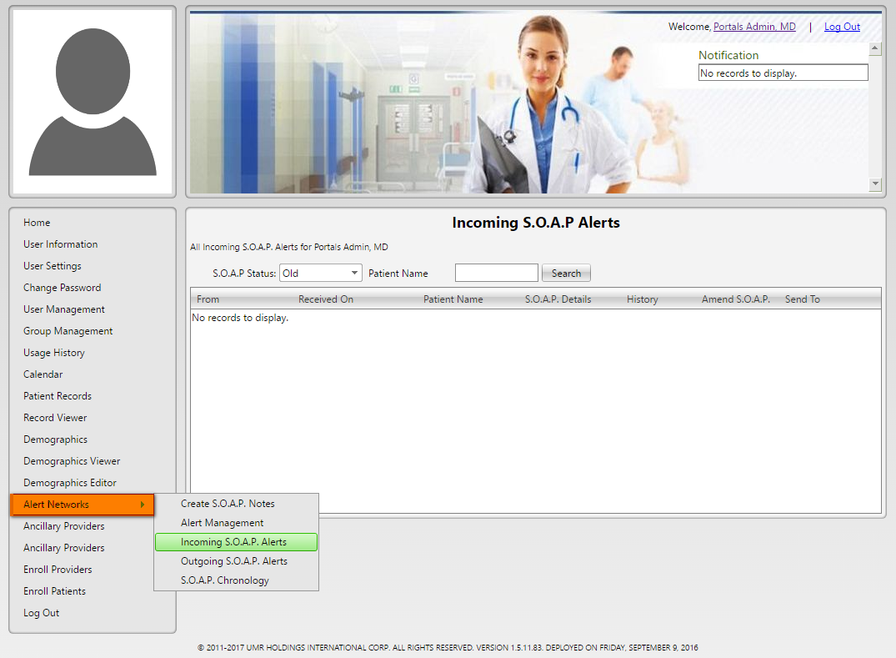

**(Image 18.2: Alert Network >> Incoming SOAP Alert)**

**NOTE: Other links are related to Create SOAP (Image 13.2 (1 to 7) And (Image 18.1.2: Alert Networks >> Alert Management - View History)**

**18.3)** **<http://umrtest.com/UMRPortals/AlertNetwork/OutgoingAlert.aspx>**

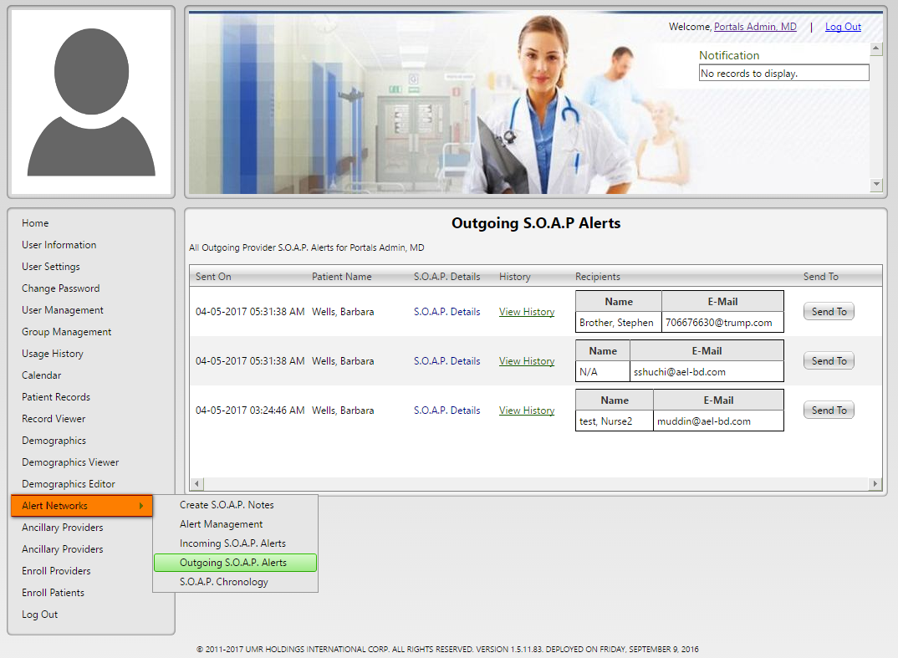

**(Image 18.3: Alert Network >> Outgoing SOAP Alert)**

**NOTE: Other links are related to Create SOAP (Image 13.2 (1 to 7) And (Image 18.1.2: Alert Networks >> Alert Management - View History)**

***Back to index***

**18.4)** **<http://umrtest.com/UMRPortals/AlertNetwork/AlertChronology.aspx>**

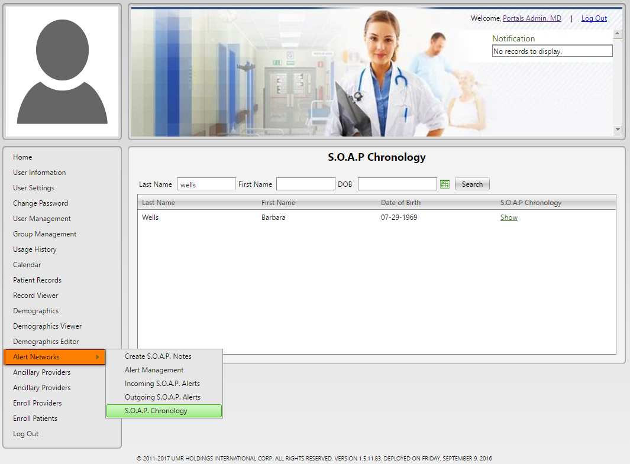

**(Image 18.4: Alert Network >> SOAP Chronology)**

**18.4.1)** **<http://umrtest.com/UMRPortals/AlertNetwork/AlertChronology.aspx>**

[**http://umrtest.com/UMRPortals/AlertNetwork/AlertChronologyList.aspx?PatientKey=3**](http://umrtest.com/UMRPortals/AlertNetwork/AlertChronologyList.aspx?PatientKey=3)

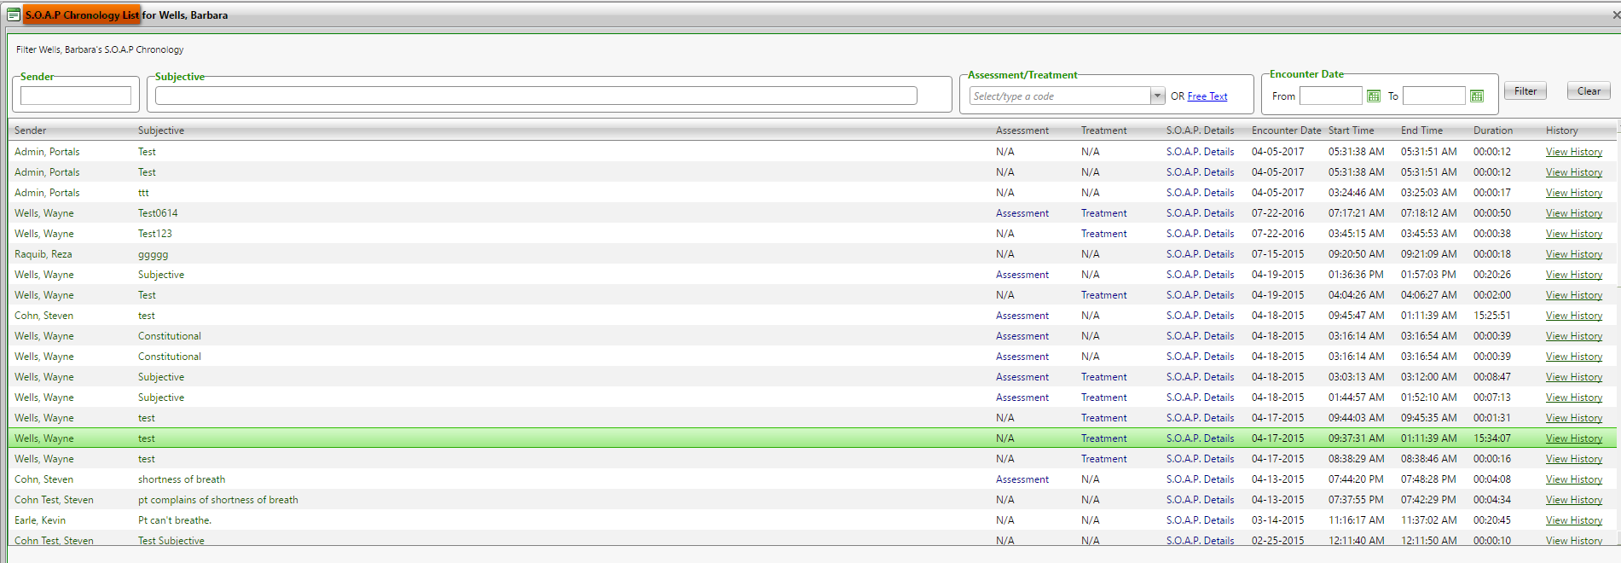

**(Image 18.4.1: SOAP Chronology >> List)**

**NOTE: Other links are related to Create SOAP (Image 13.2 (1 to 7) And (Image 18.1.2: Alert Networks >> Alert Management - View History)**

***Back to index***

1. **<http://umrtest.com/UMRPortals/PatientFeatures/PatientSecondUserMgt.aspx>**

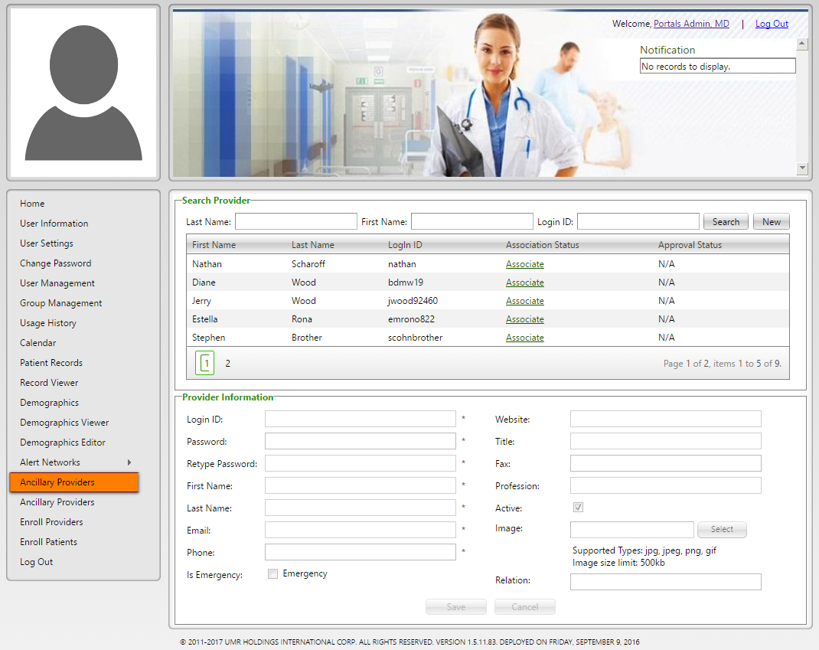

**(Image 19: Patient’s Ancillary Providers)**

1. **<http://umrtest.com/UMRPortals/Administrative/ManageSecondaryUser.aspx>**

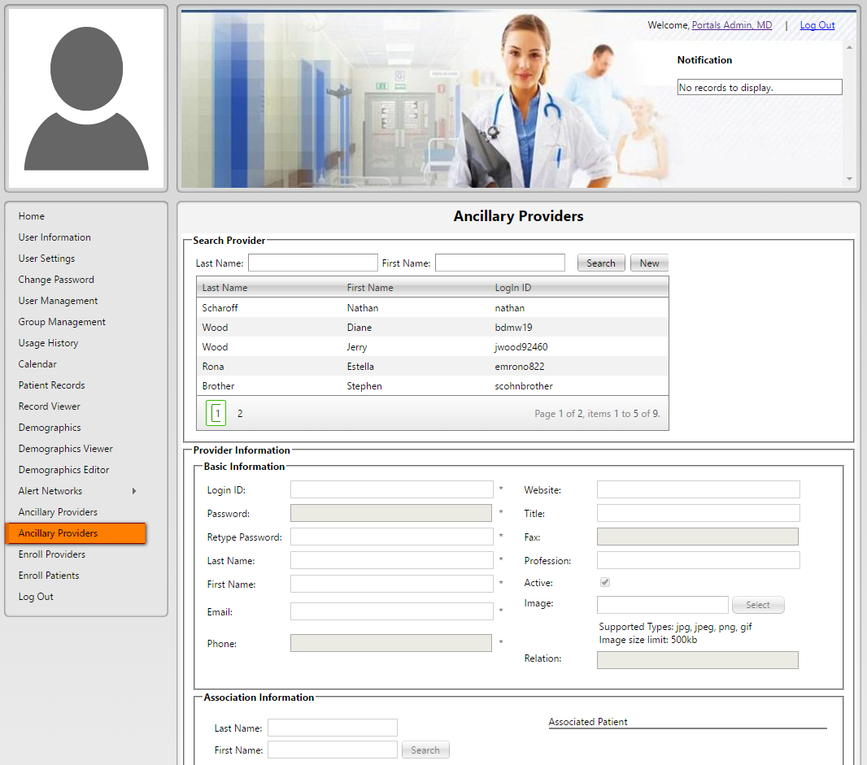

**(Image 20: Admin’s Ancillary Providers)**

***Back to index***

1. **<http://umrtest.com/UMRPortals/Administrative/SignUpAprroval.aspx>**

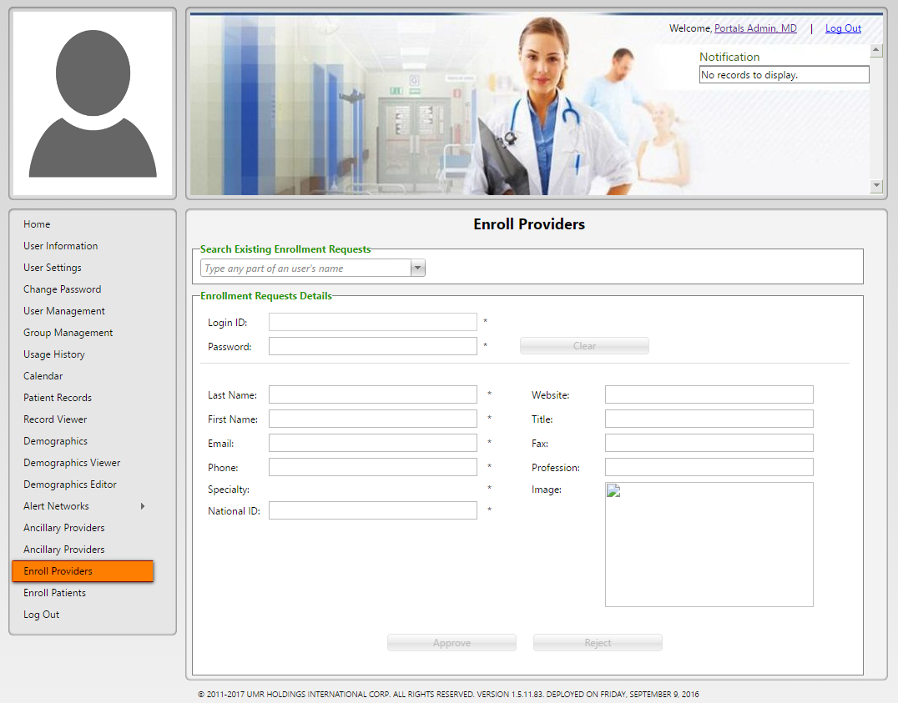

**(Image 21: Enroll Providers)**

1. **<http://umrtest.com/UMRPortals/Administrative/SingUpApprovalPatient.aspx>**

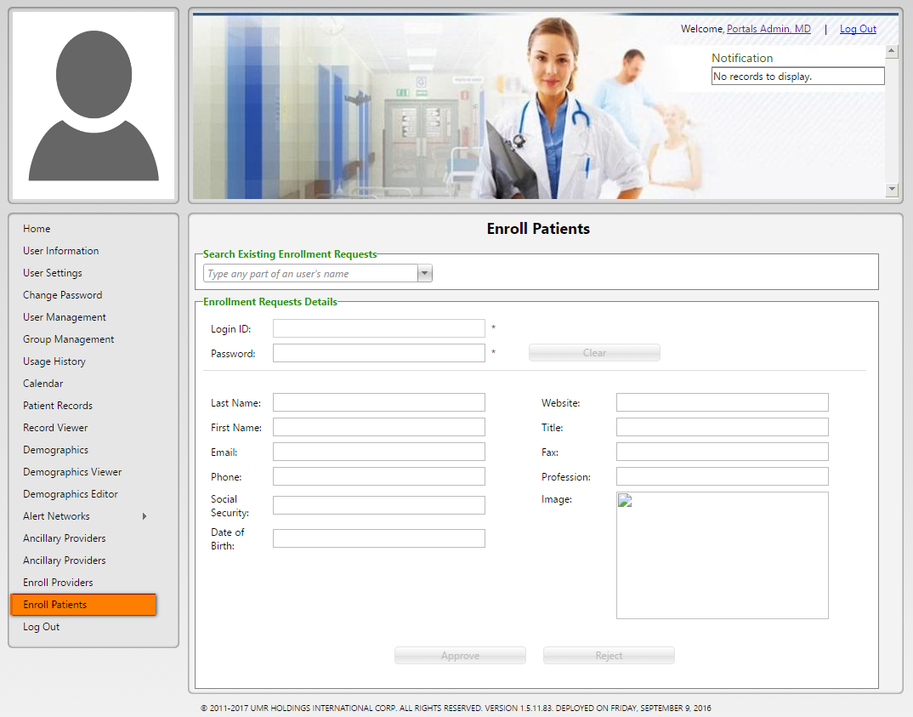

**(Image 22: Enroll Patients)**

***Back to index***